**Introduction**

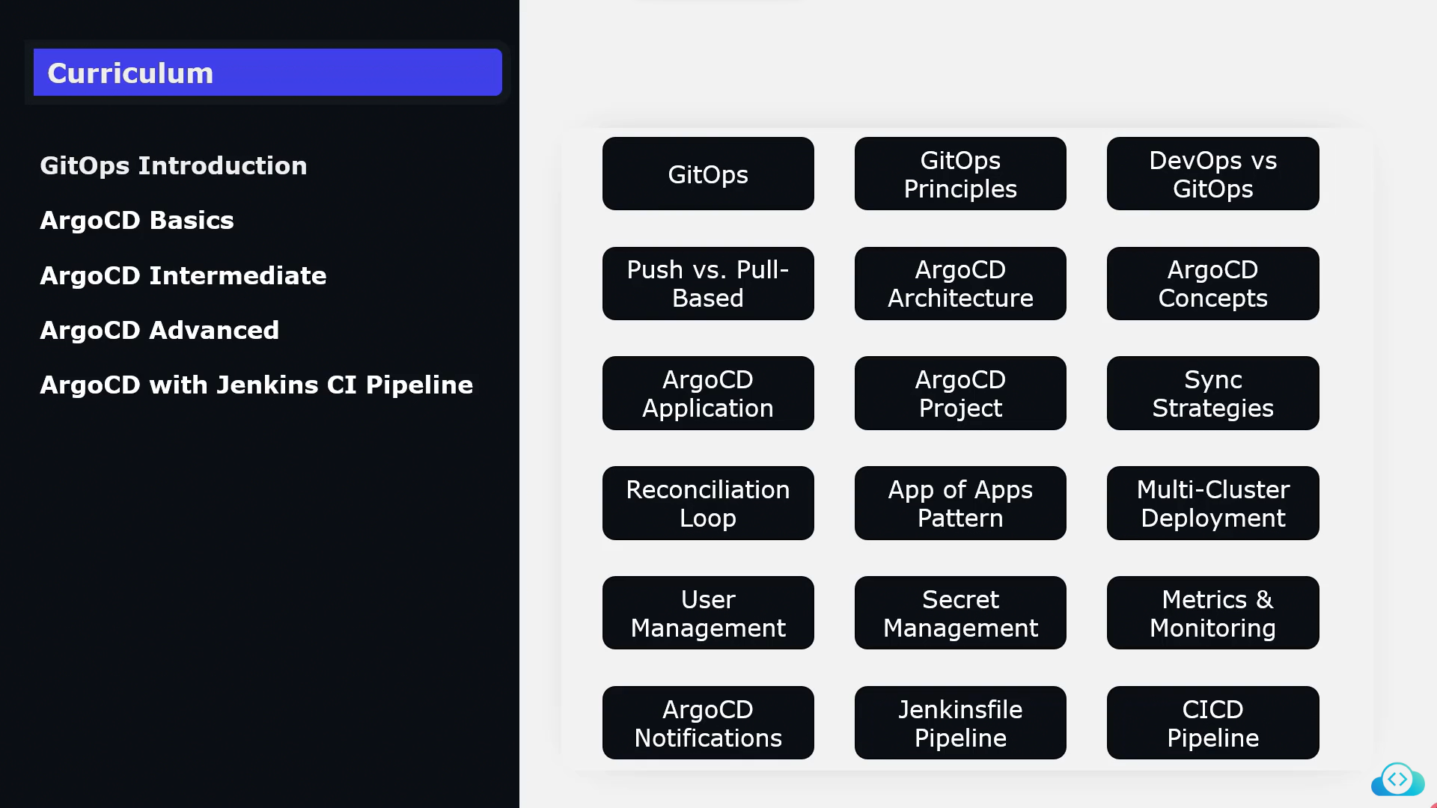

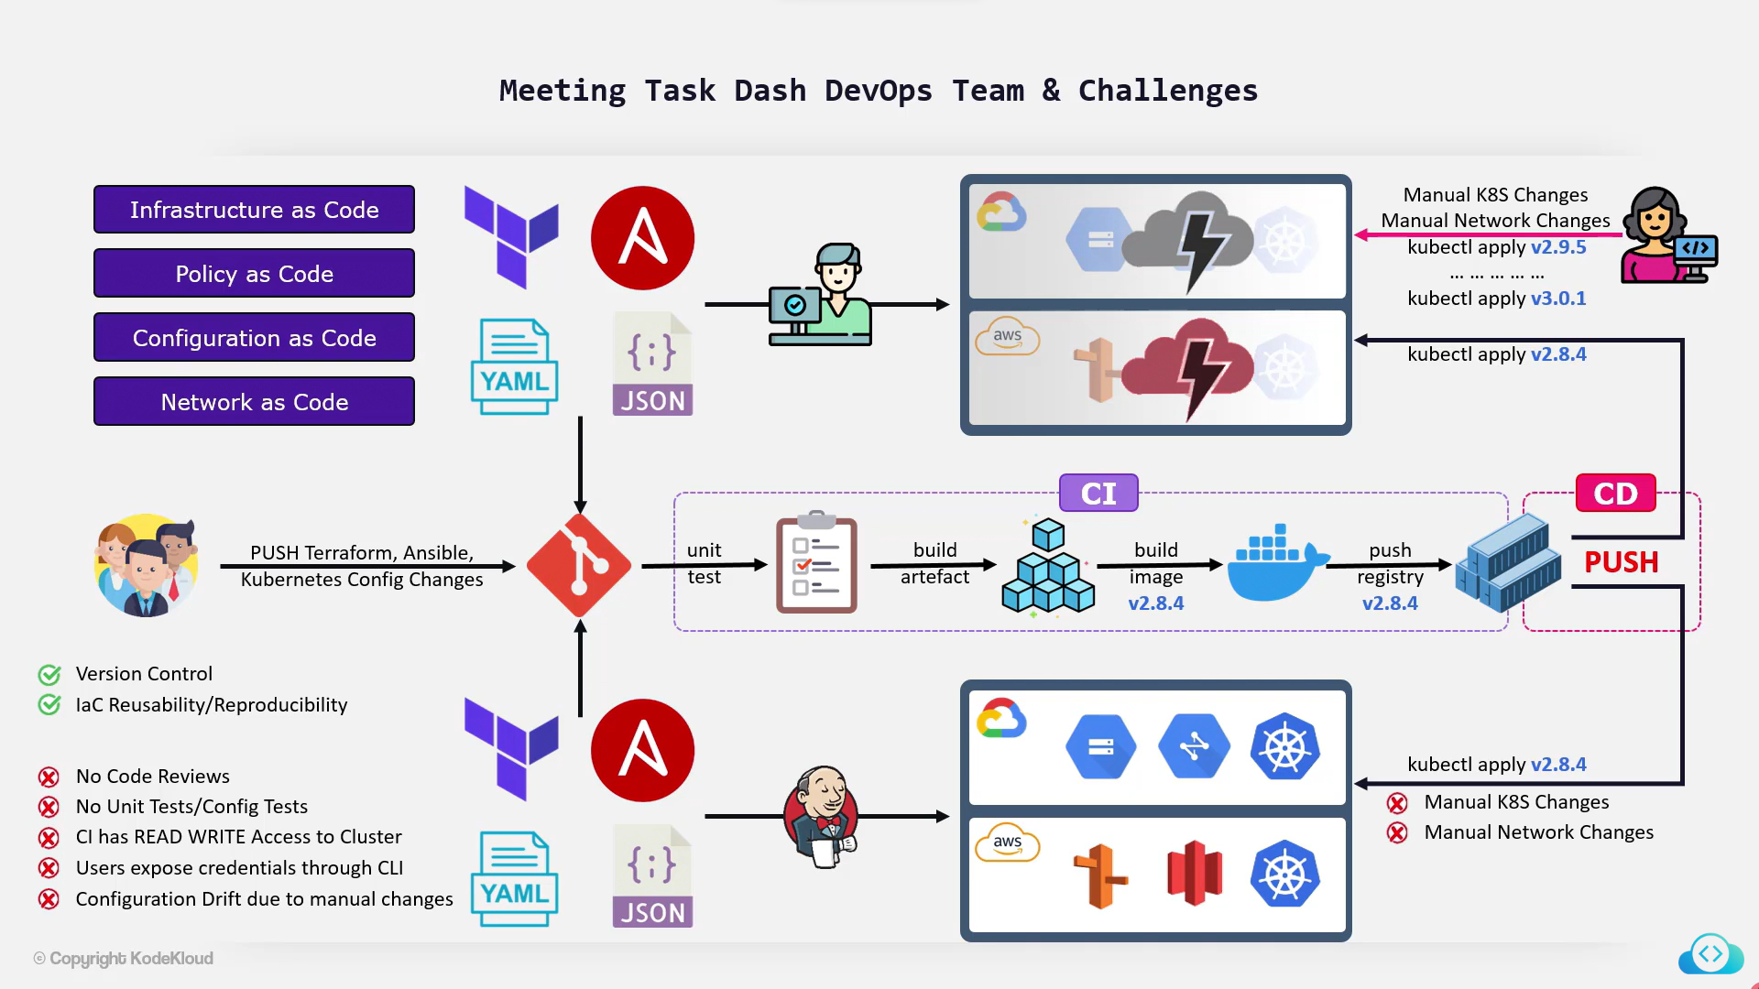

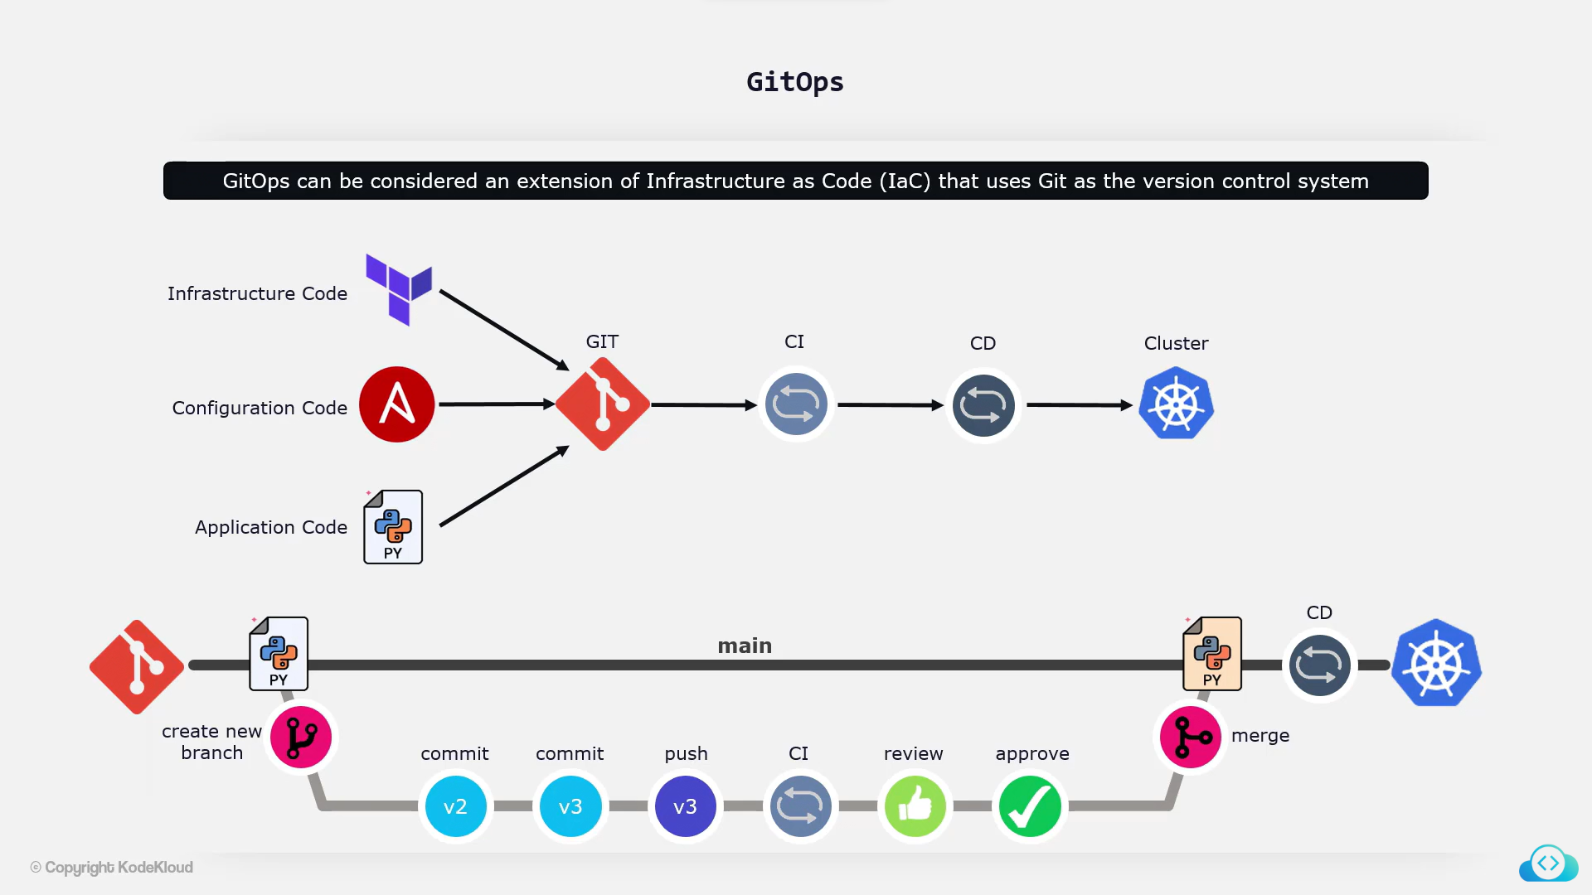

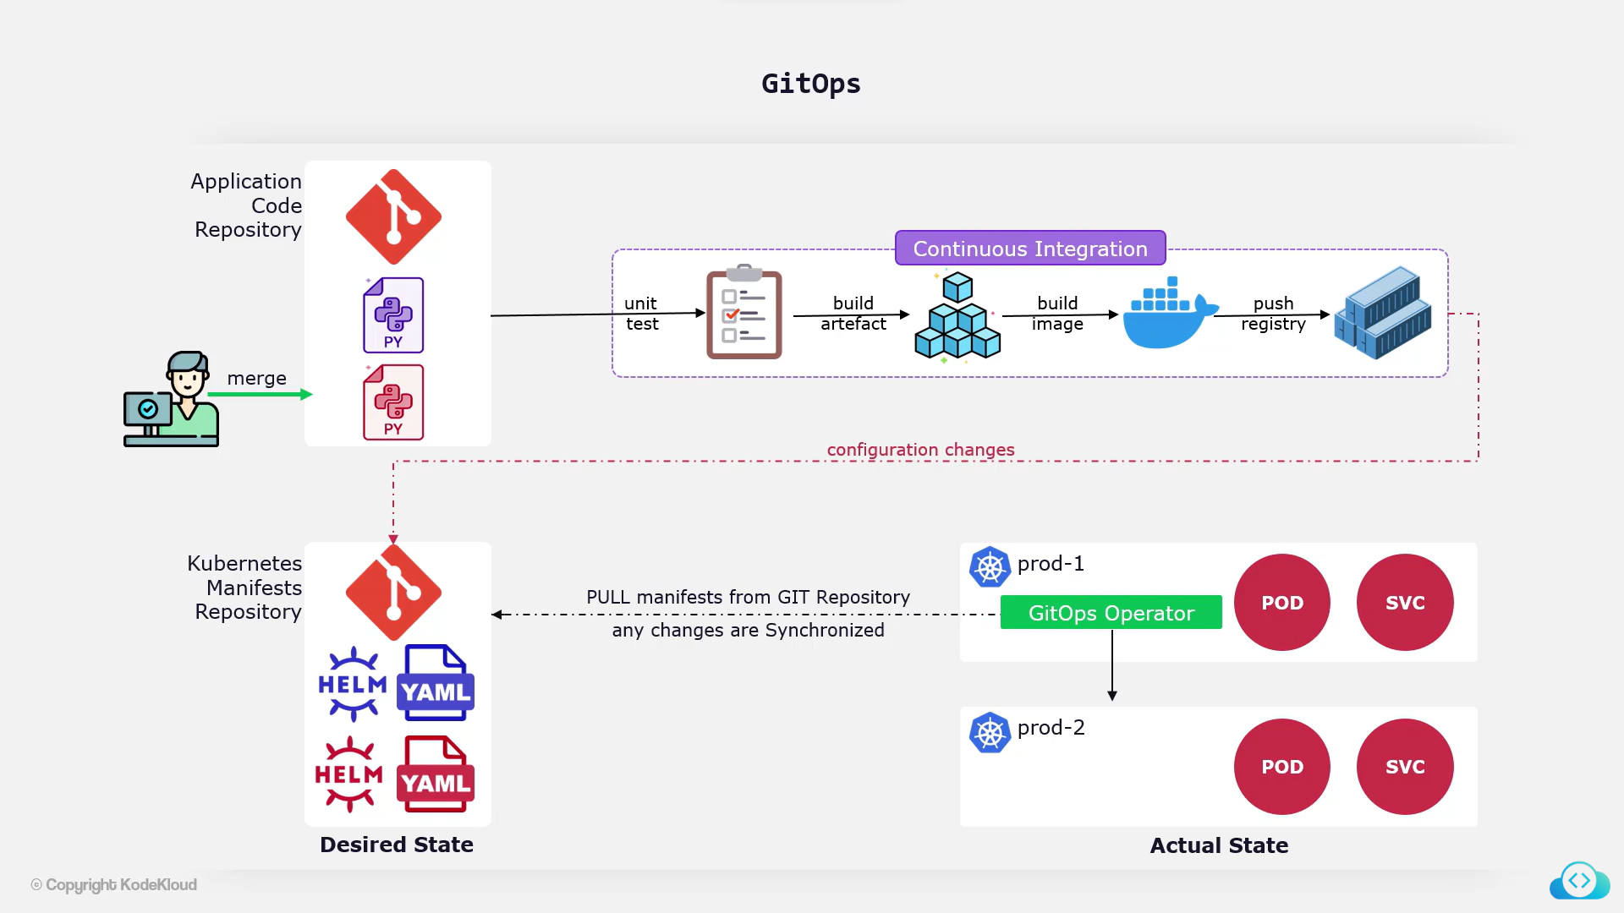

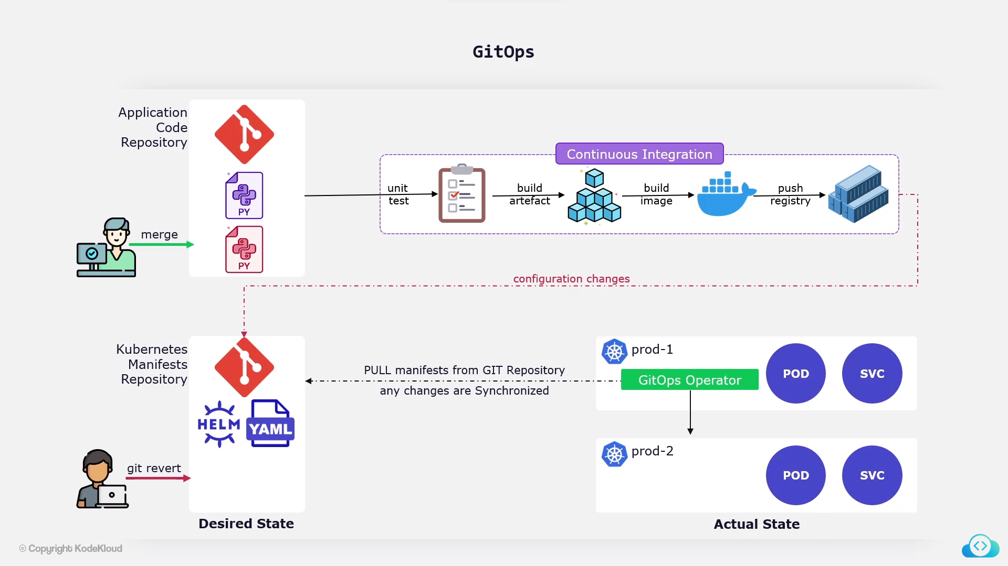

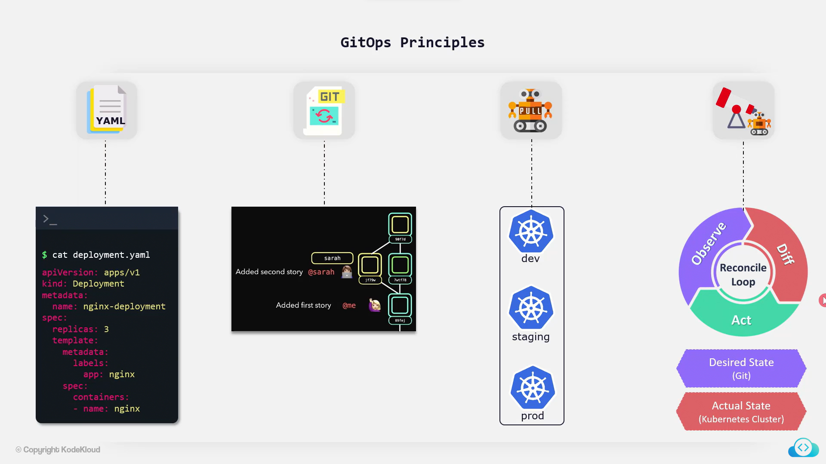

**GitOps Introduction**

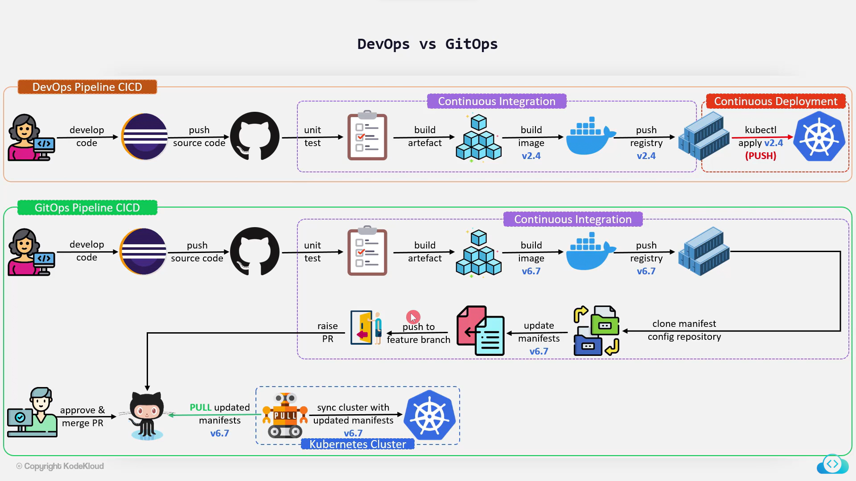

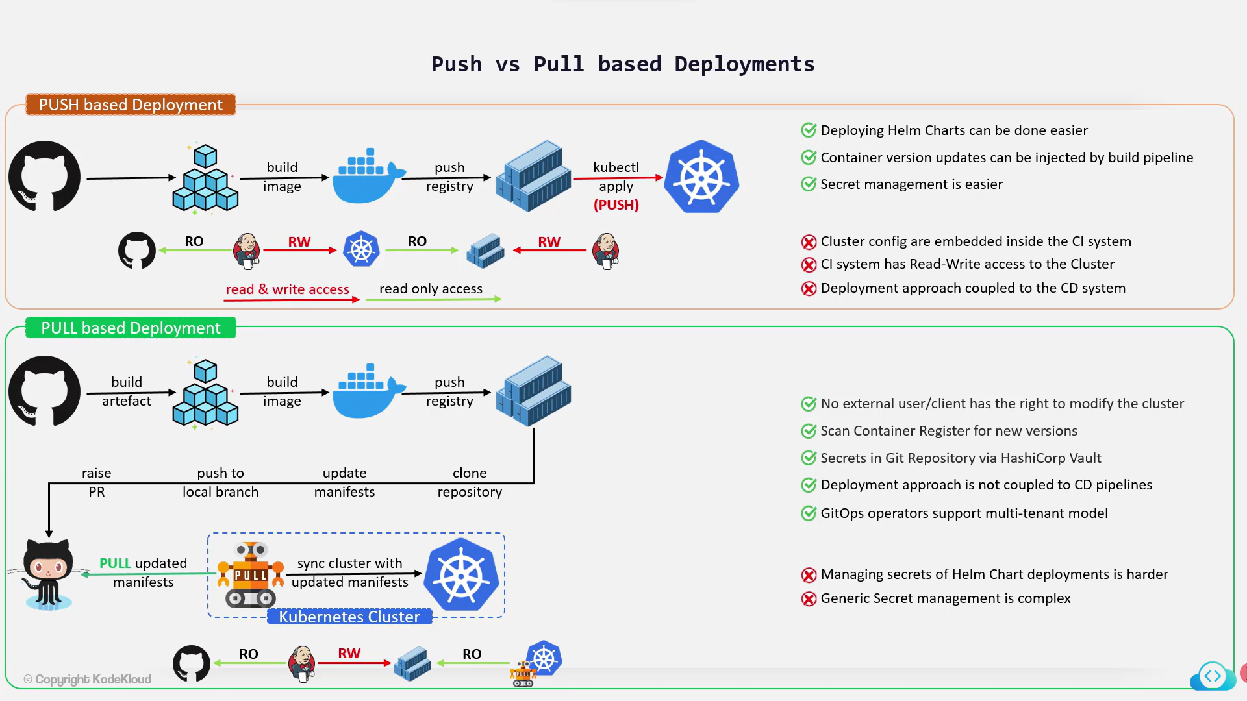

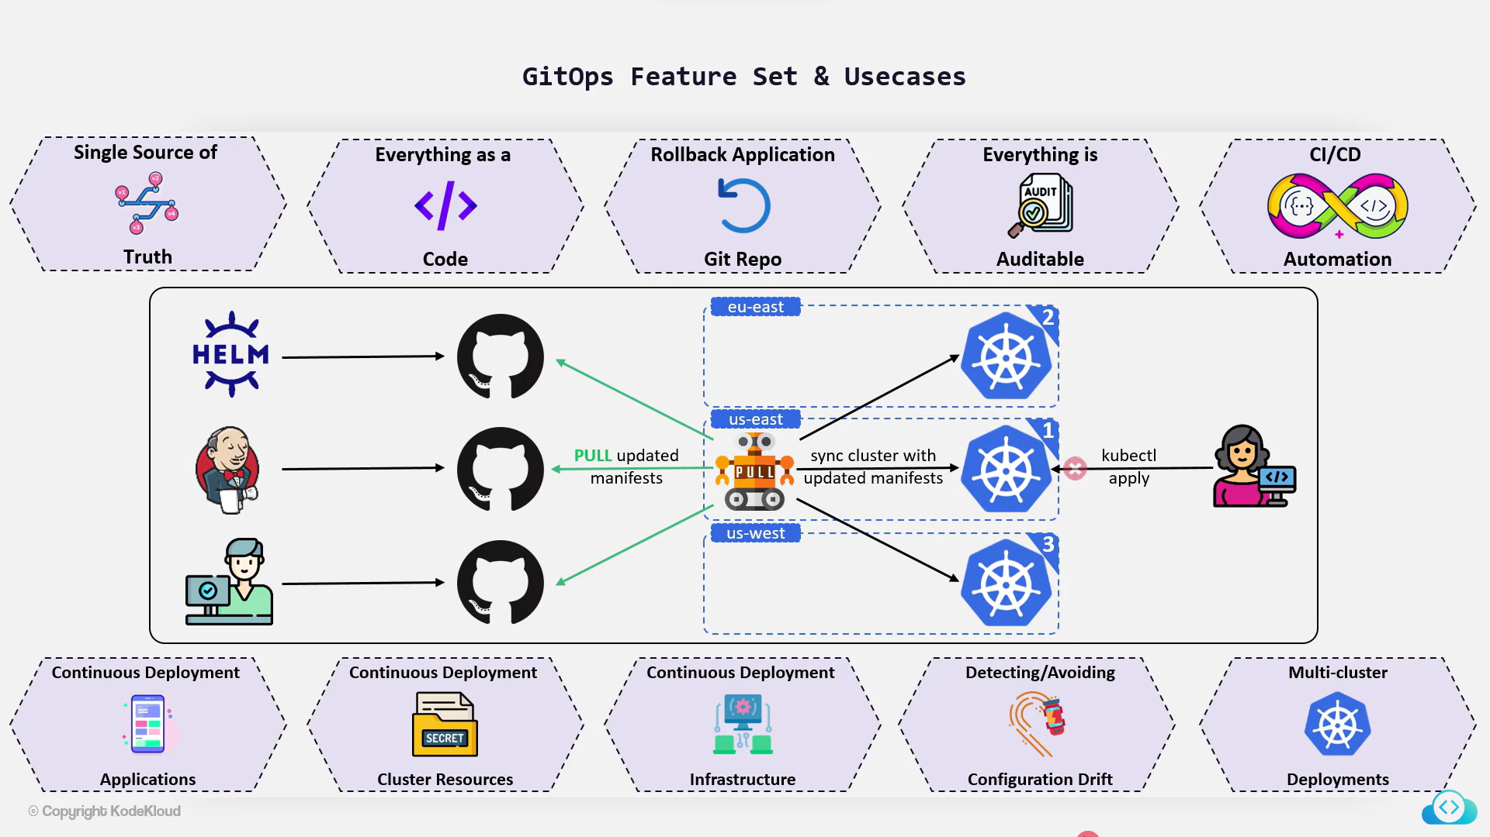

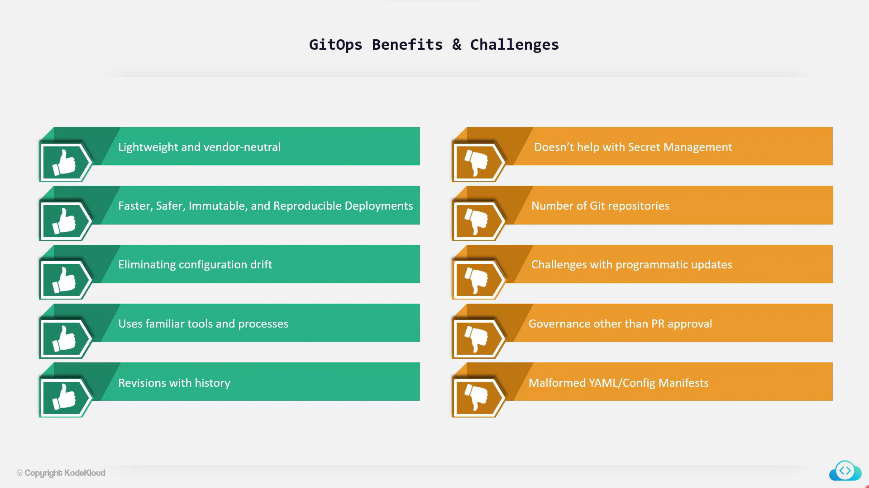

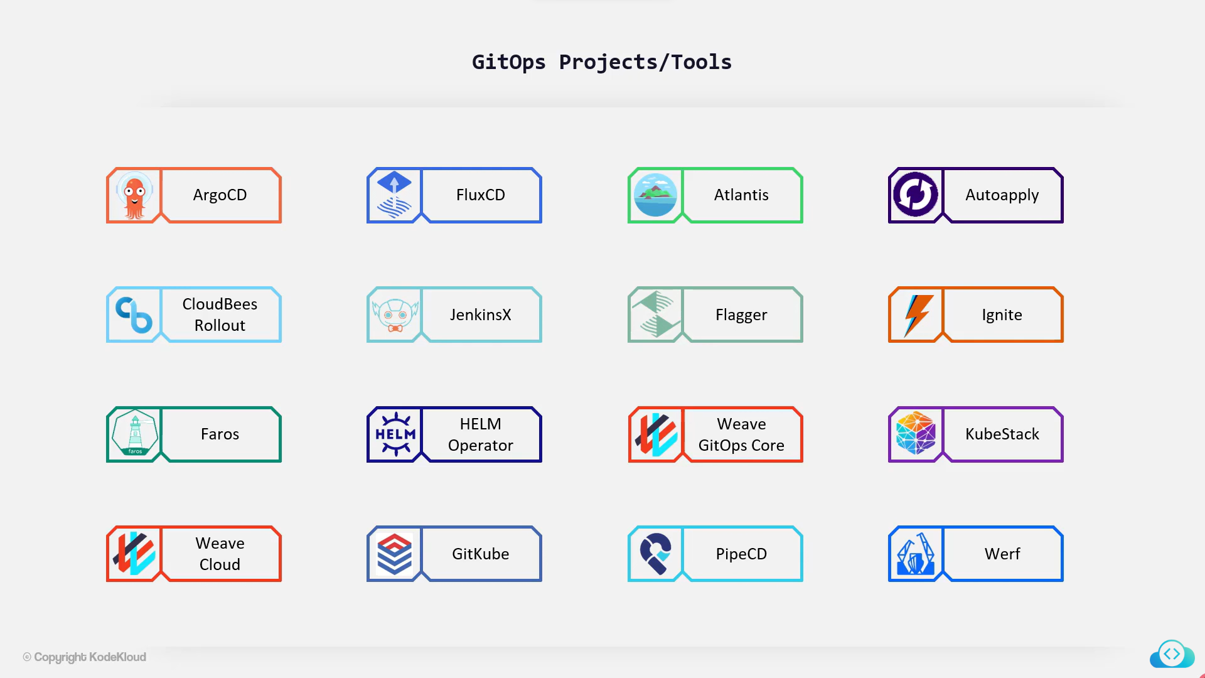

**ArgoCD Basics**

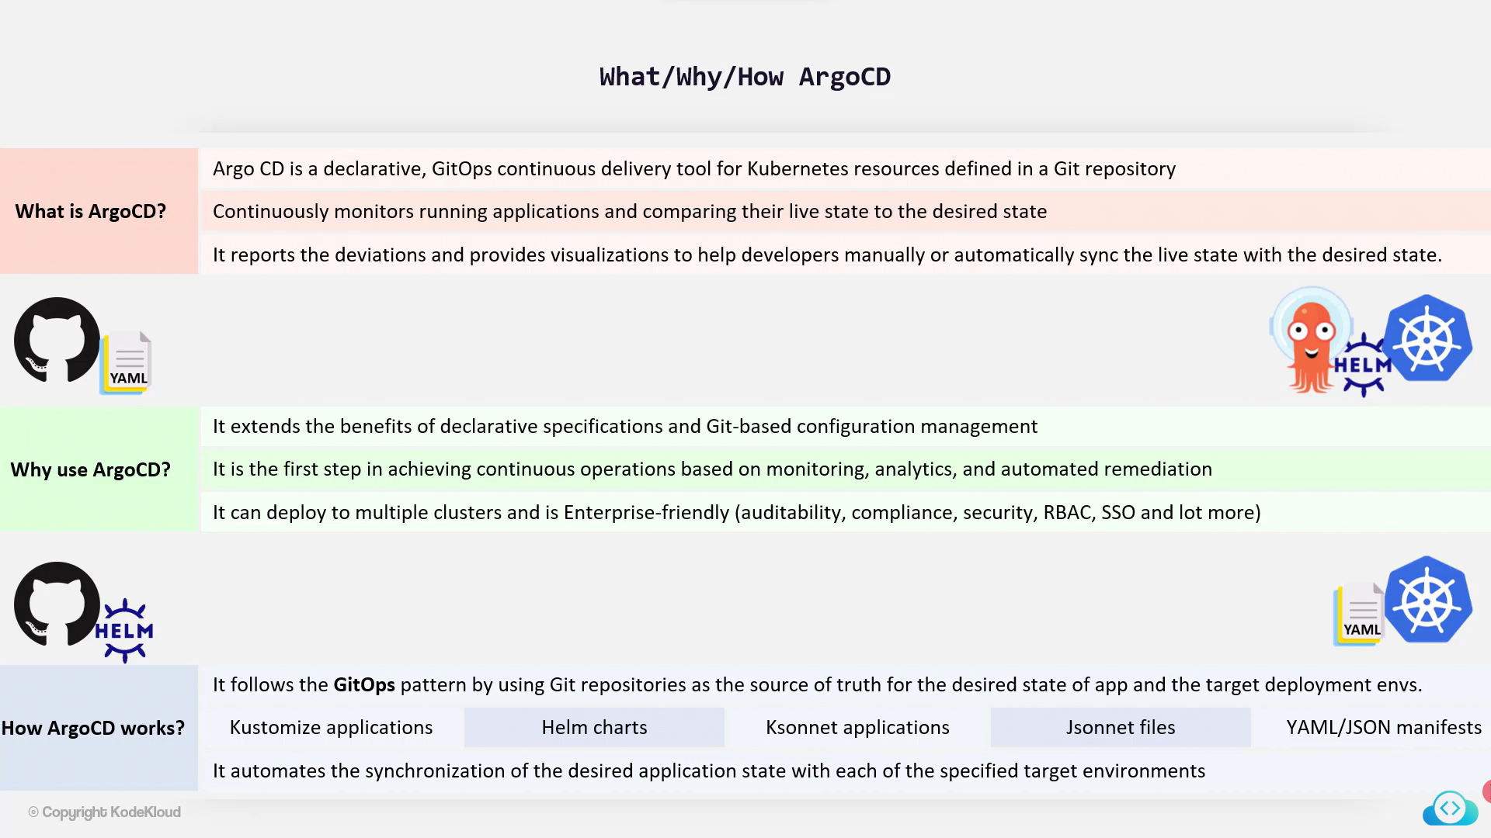

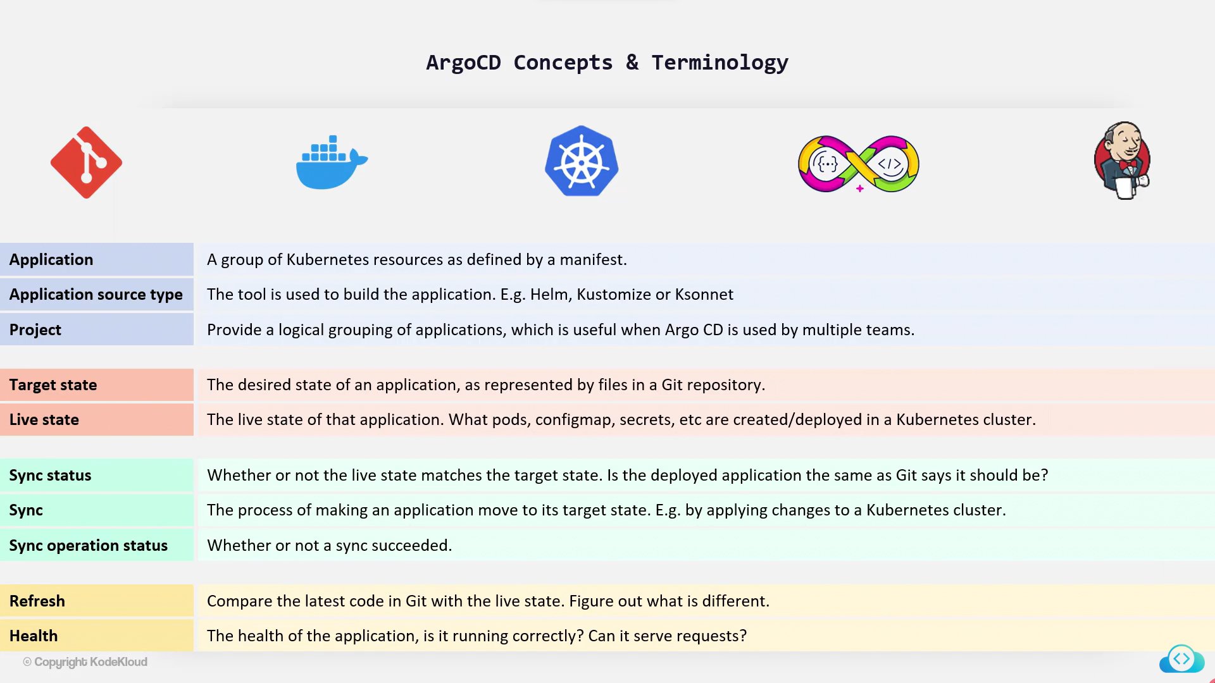

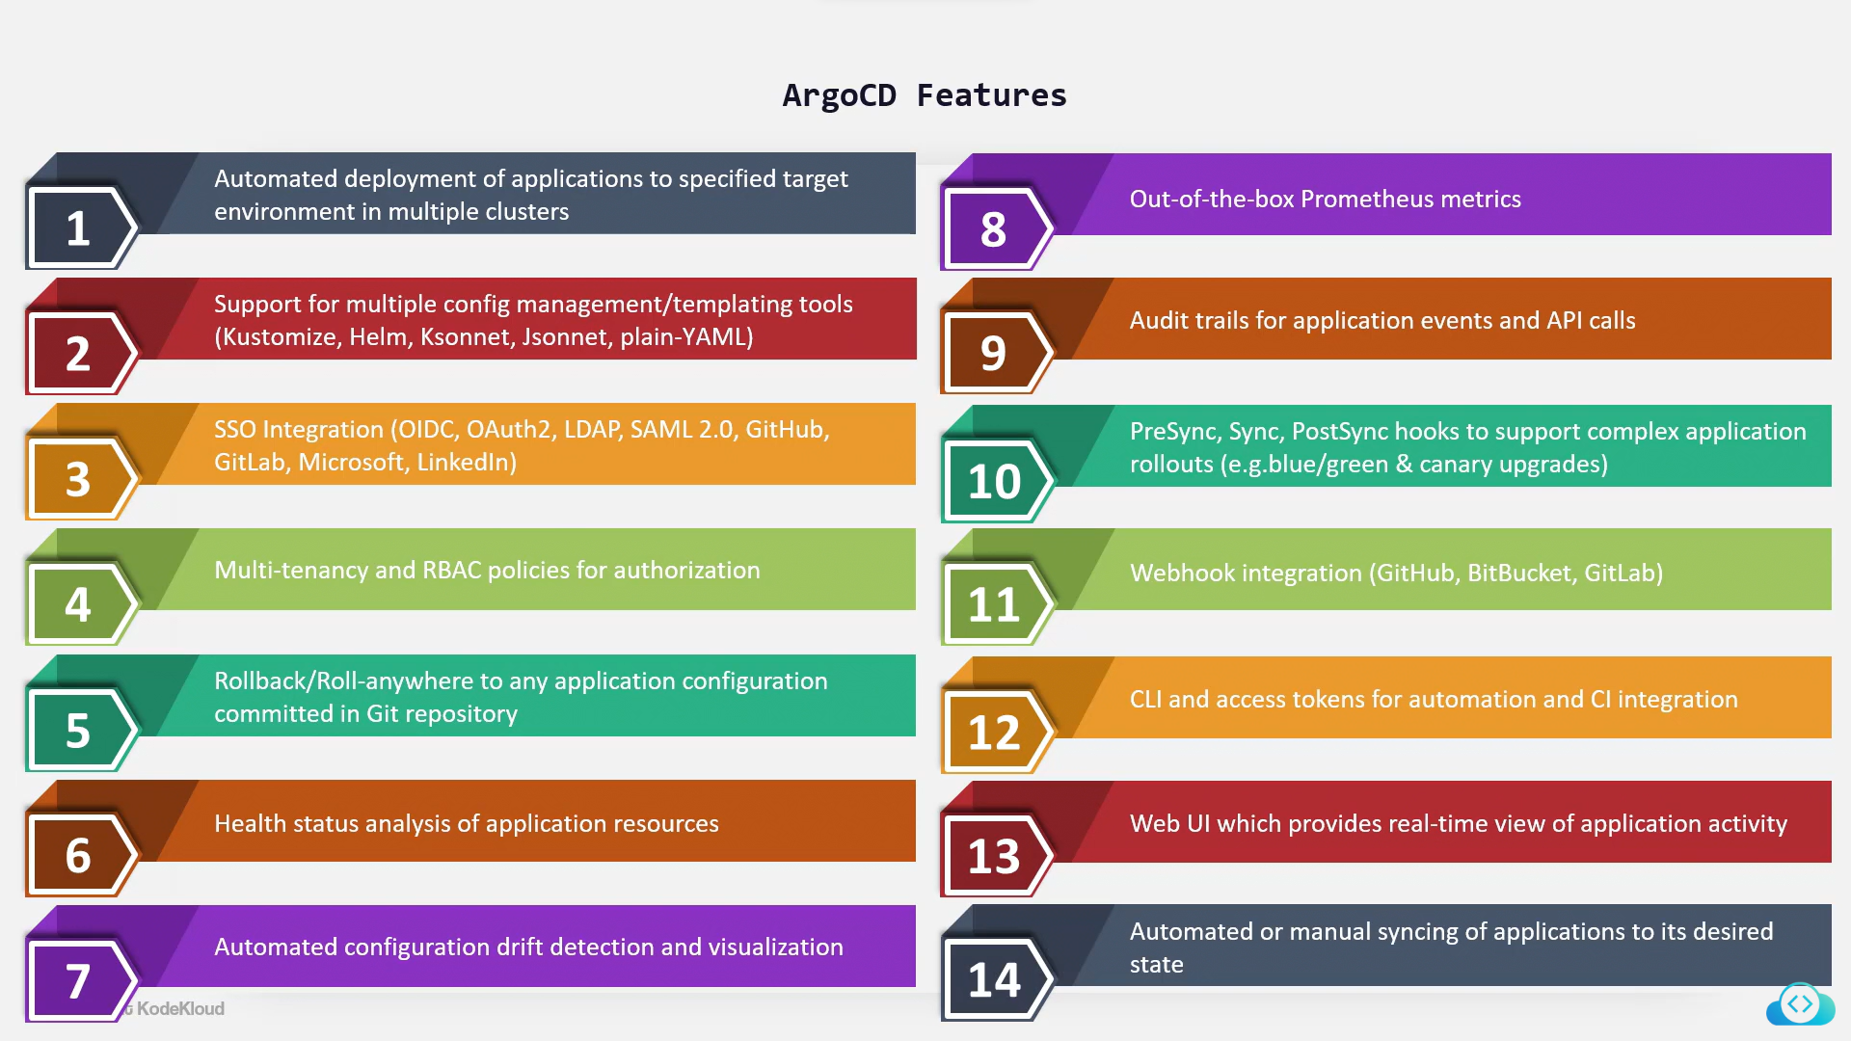

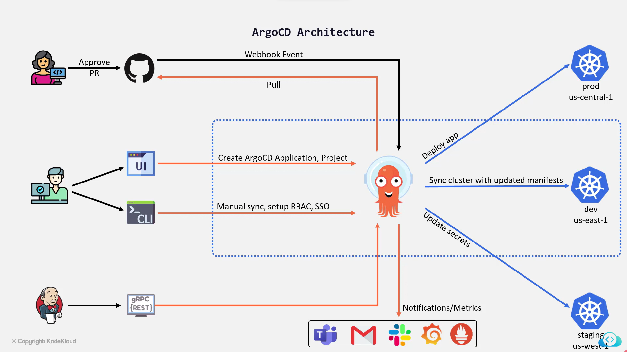

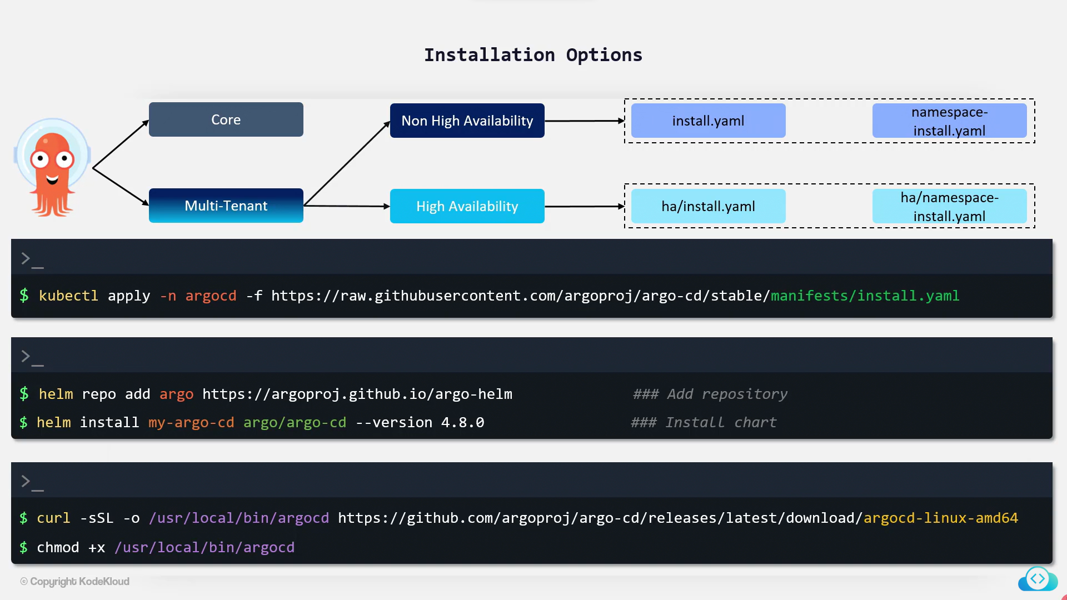

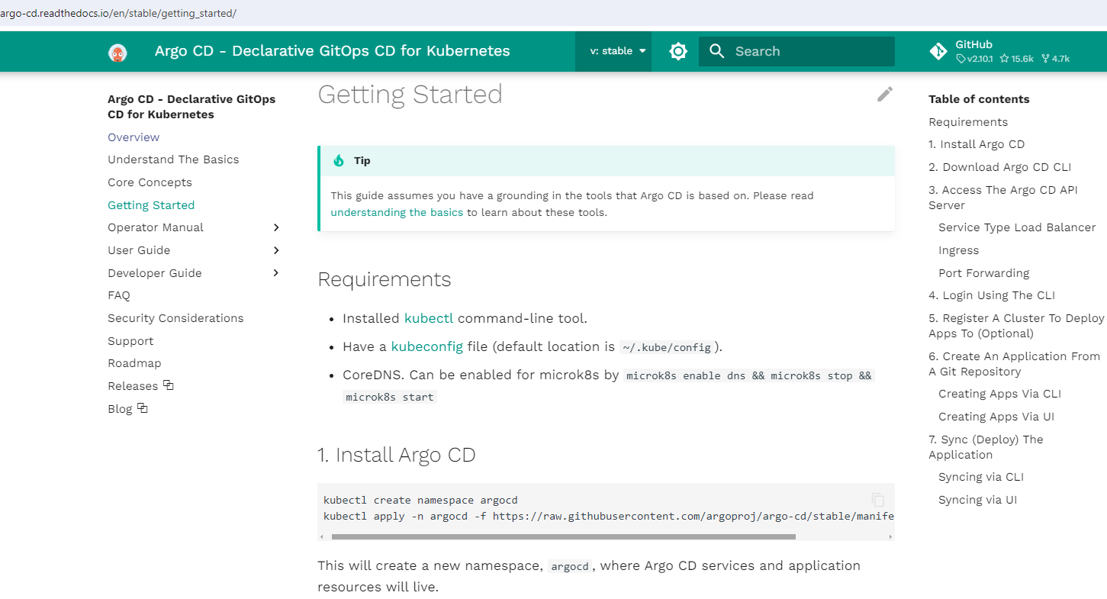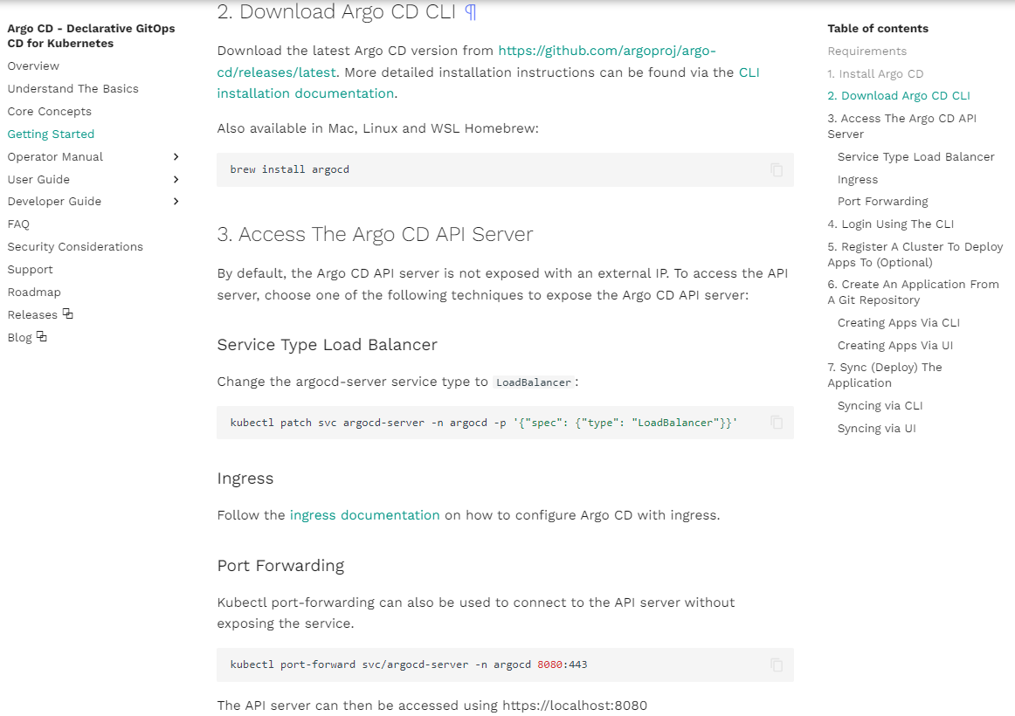

**Lab – Setup ArgoCD Server and CLI**

Ex 1:

Install a Non-HA v2.4.11 ArgoCD within argocd namespace.

<https://github.com/argoproj/argo-cd/releases>

Solution:

Create a namespace called argocd:

kubectl create namespace argocd

To install Non-HA v2.4.11 ArgoCD within argocd namespace run the below command:

kubectl apply -n argocd -f https://raw.githubusercontent.com/argoproj/argo-cd/v2.4.11/manifests/install.yaml

Ex 2:

How many data entries does argocd-cm config map have?

Solution:

You can check the argocd-cm config map data entries using kubectl -n argocd get cm argocd-cm command.

controlplane ~ ➜ kubectl -n argocd get cm argocd-cm

NAME DATA AGE

argocd-cm 0 65s

Ex 3:

Which of the following ports does argocd-server listen on?

Solution:

You can check the ports used by argocd-server using kubectl -n argocd get svc argocd-server command.

argocd-server listens on port 80 and 443.

controlplane ~ ➜ kubectl -n argocd get svc argocd-server

NAME TYPE CLUSTER-IP EXTERNAL-IP PORT(S) AGE

argocd-server ClusterIP 10.107.121.247 <none> 80/TCP,443/TCP 7m13s

Ex 4:

Access the ArgoCD-UI by converting the ArgoCD Server service from type ClusterIP to NodePort.  
  
Use node port 32766 for https port.

Solution:

Edit the ArgoCD Server service and convert it from type ClusterIP to NodePort:

kubectl edit svc argocd-server -n argocd

Change type: ClusterIP to type: NodePort and under - name: https add nodePort: 32766

Ex 5:

After base64 decoding, which one of the following shows the Argocd Initial Admin Password you just setup?

Solution:

Fetch the ArgoCD initial Admin Password using kubectl -n argocd get secrets argocd-initial-admin-secret -o json | jq .data.password -r | tr -d '\n' | base64 -d command.

controlplane ~ ➜ kubectl -n argocd get secrets argocd-initial-admin-secret -o json{

"apiVersion": "v1",

"data": {

"password": "NHZKN1drQ0ZuMmR0b2ppWQ=="

},

"kind": "Secret",

"metadata": {

"creationTimestamp": "2024-02-29T15:00:04Z",

"name": "argocd-initial-admin-secret",

"namespace": "argocd",

"resourceVersion": "5136",

"uid": "887bdb46-fa86-4375-82df-49ea157cf407"

},

"type": "Opaque"

}

kubectl -n argocd get secrets argocd-initial-admin-secret -o json | jq .data.password -r | tr -d '\n' | base64 -d

Ex 6:

Login into the ArgoCD-UI using below credentials:  
  
  
Username: admin  
  
  
Password: Use the same password you fetched in the previous question

Next, install ArgoCD CLI v2.4.11

curl -sSL -o /usr/local/bin/argocd https://github.com/argoproj/argo-cd/releases/download/v2.4.11/argocd-linux-amd64

chmod +x /usr/local/bin/argocd

# ArgoCD App & projects

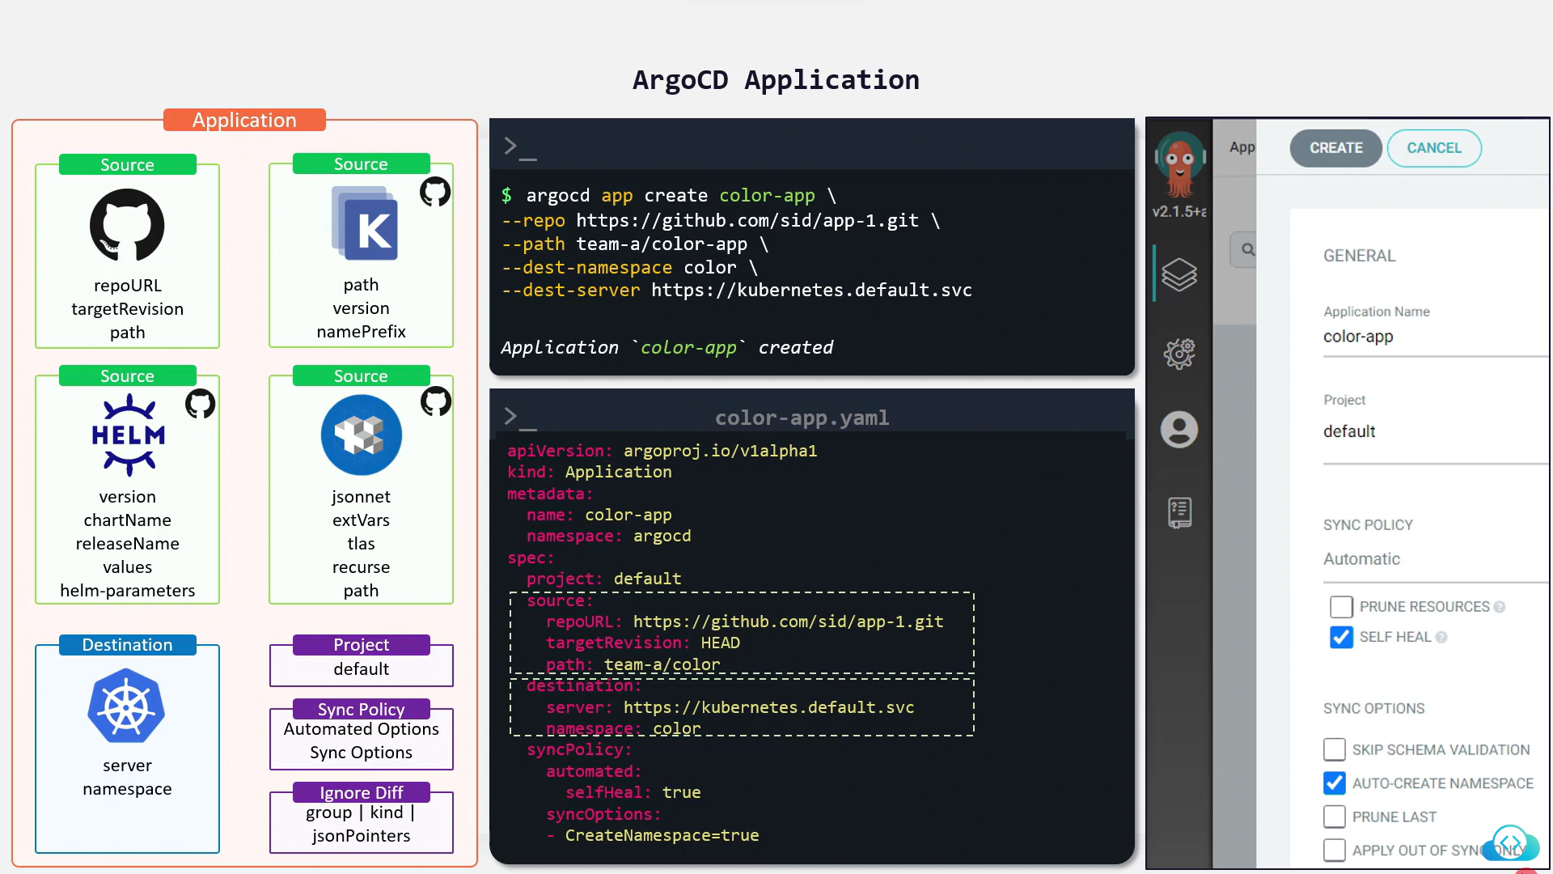

# Create Application using UI

# Create Application using CLI

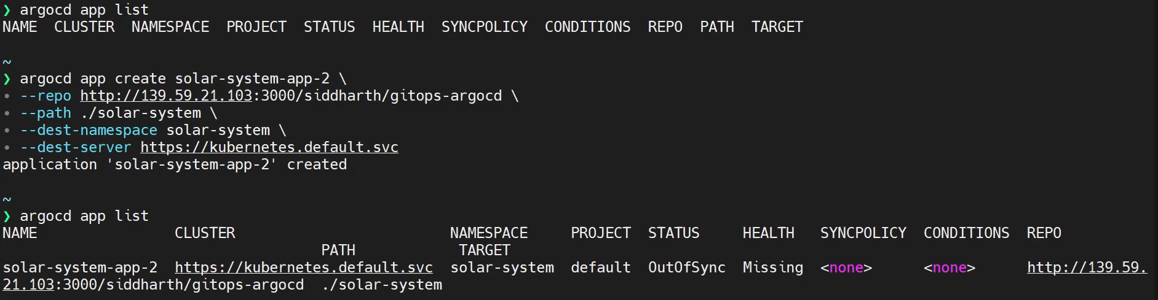



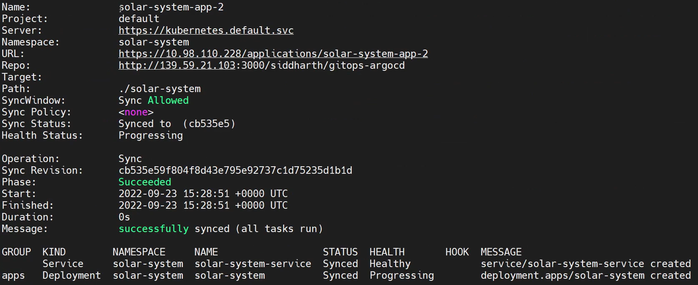

# Create ArgoCD Project

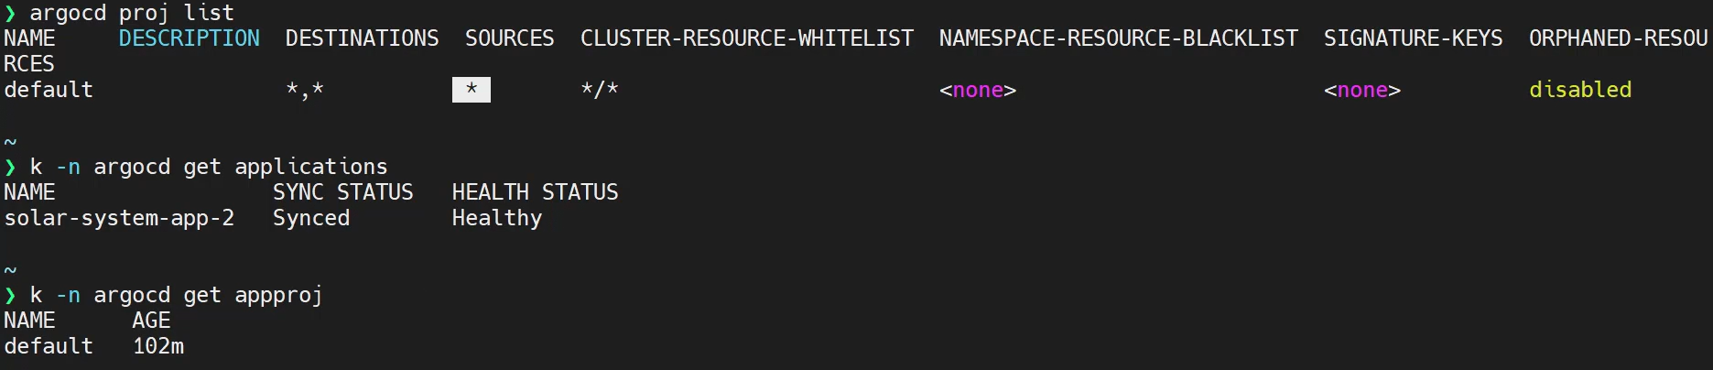

**ArgoCD Intermediate**

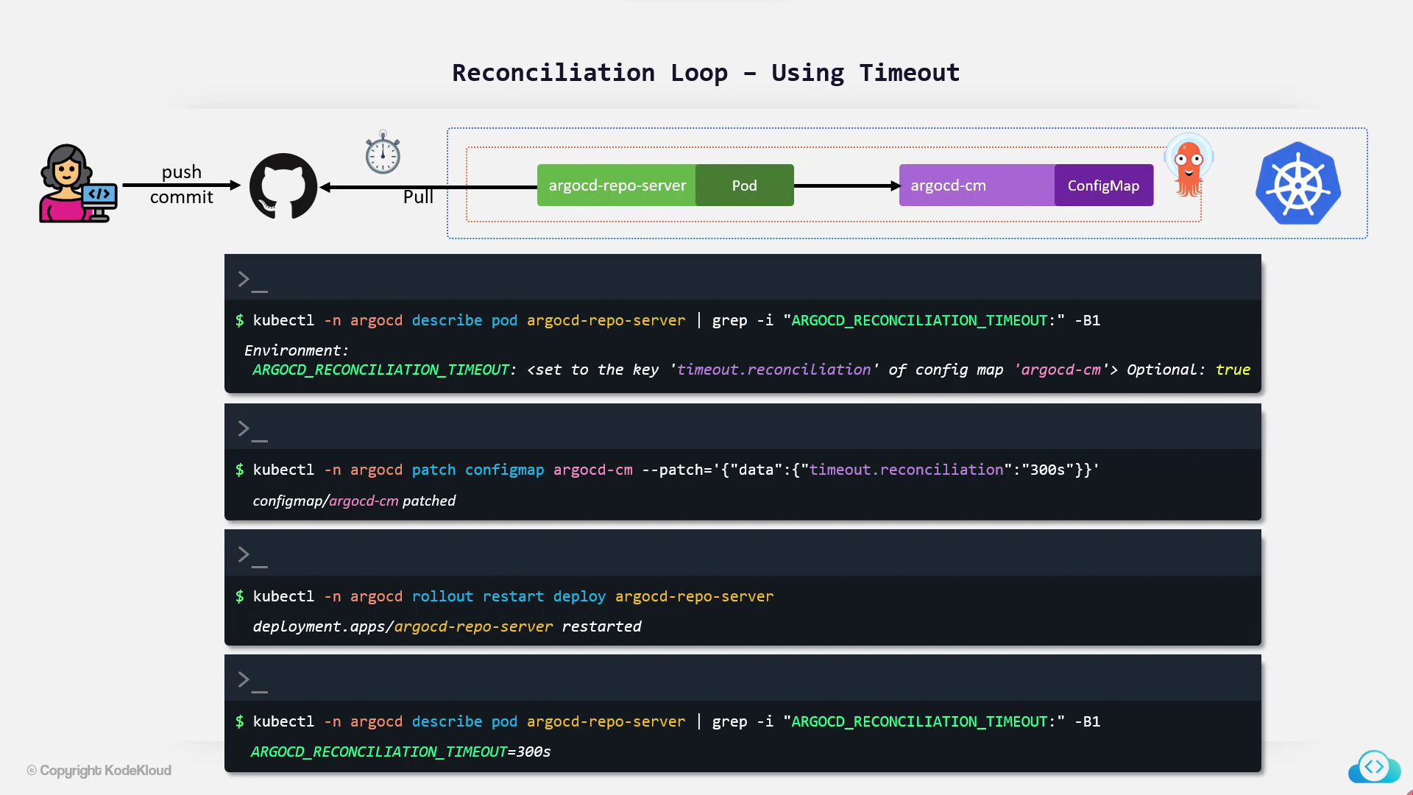

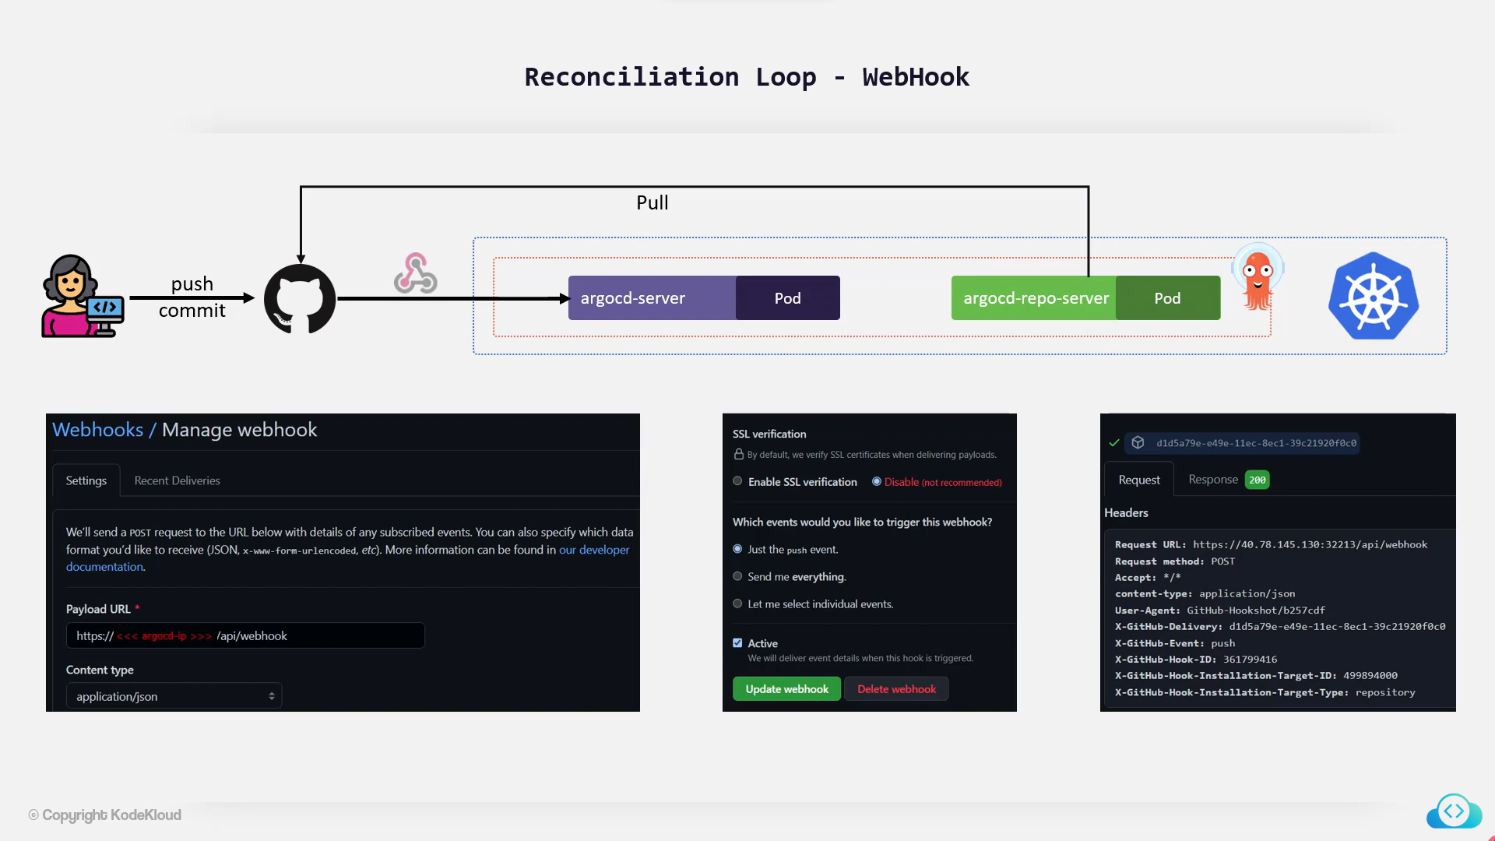

Lab – ArgoCD Application Reconciliation

<>

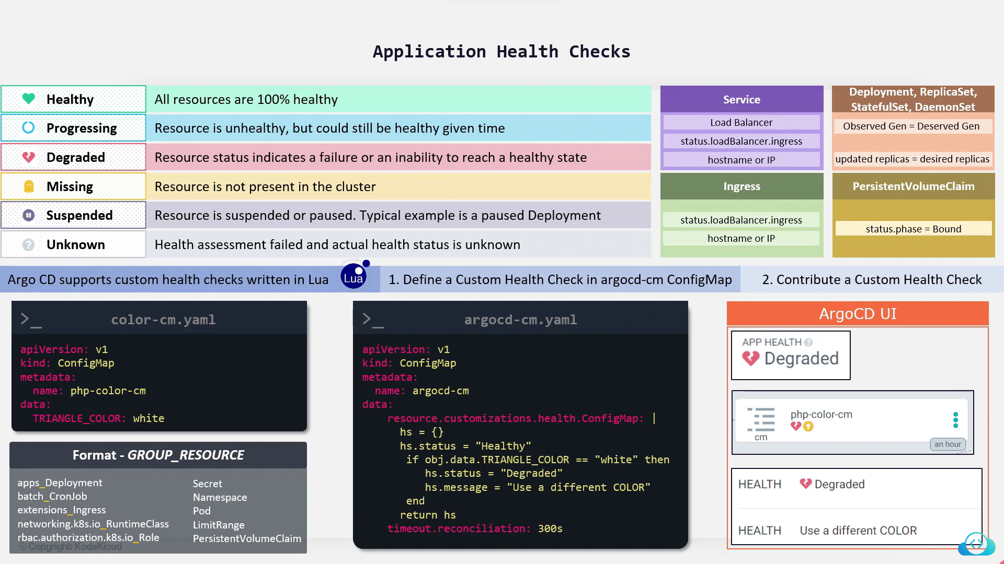

Lab - Application Custom Health Check <>

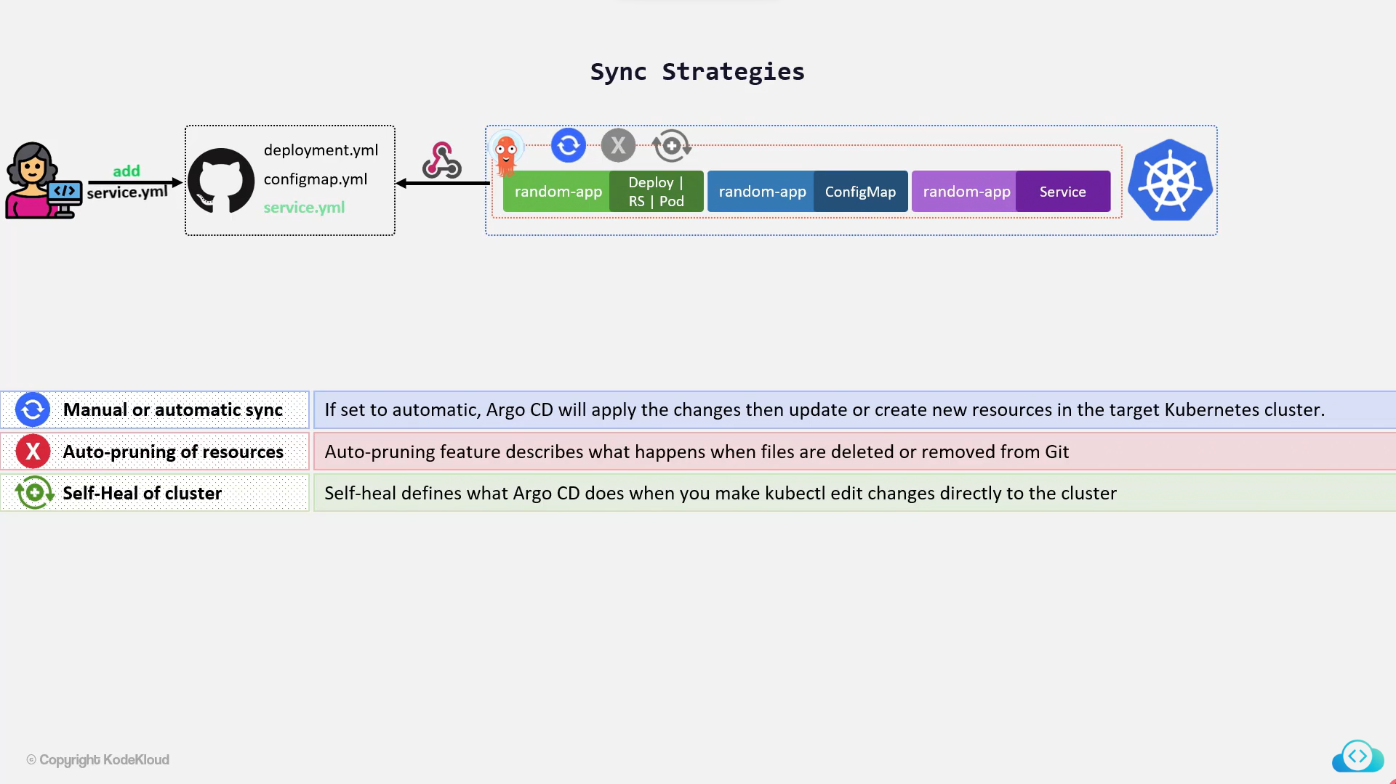

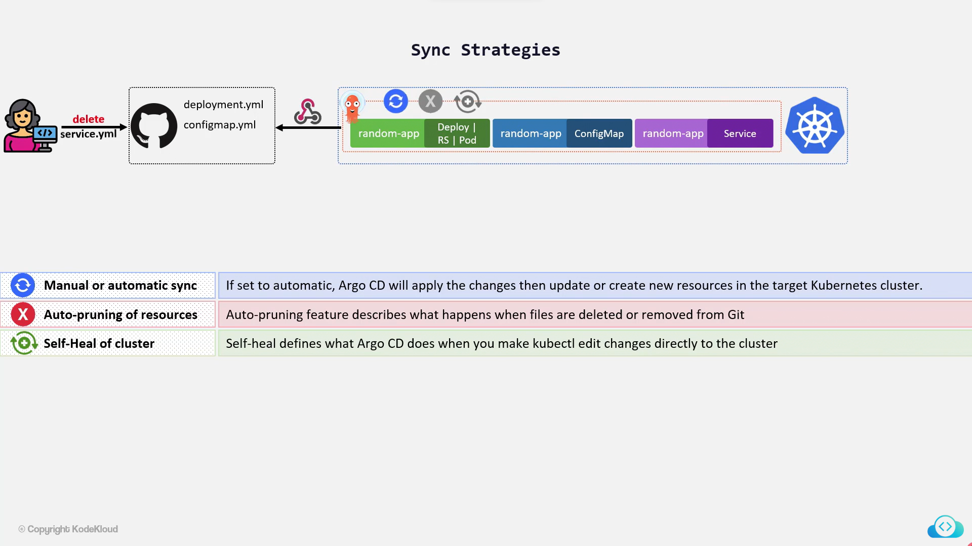

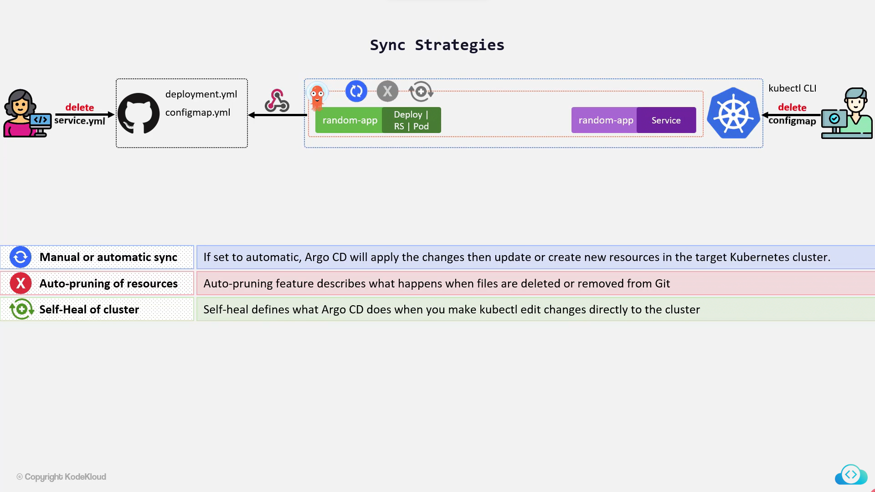

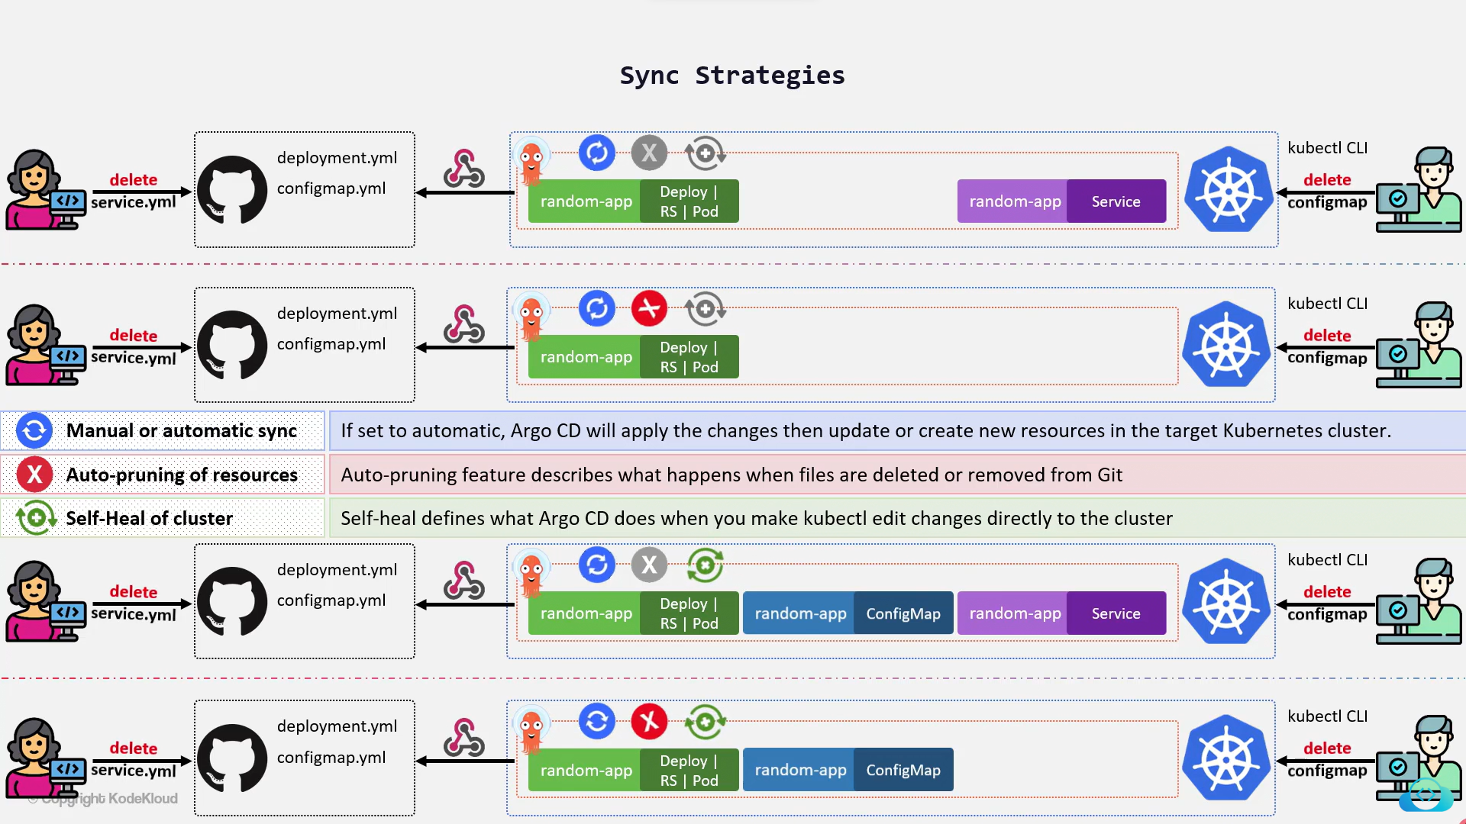

Declarative Setup

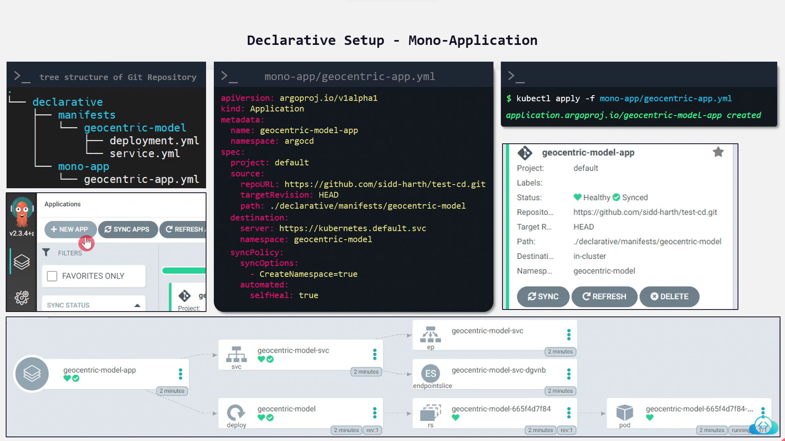

App of Apps

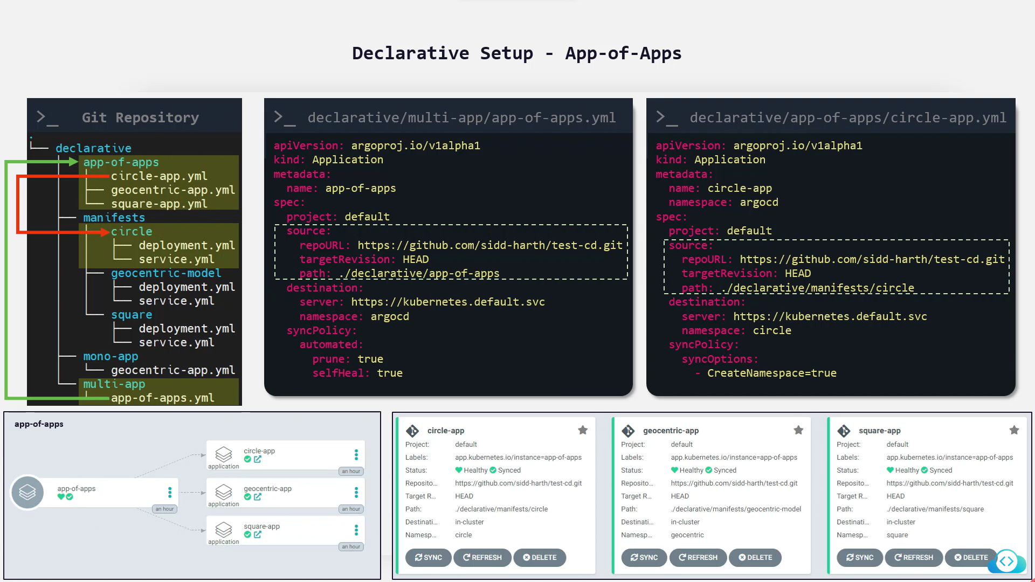

Deploy Apps using HELM Chart

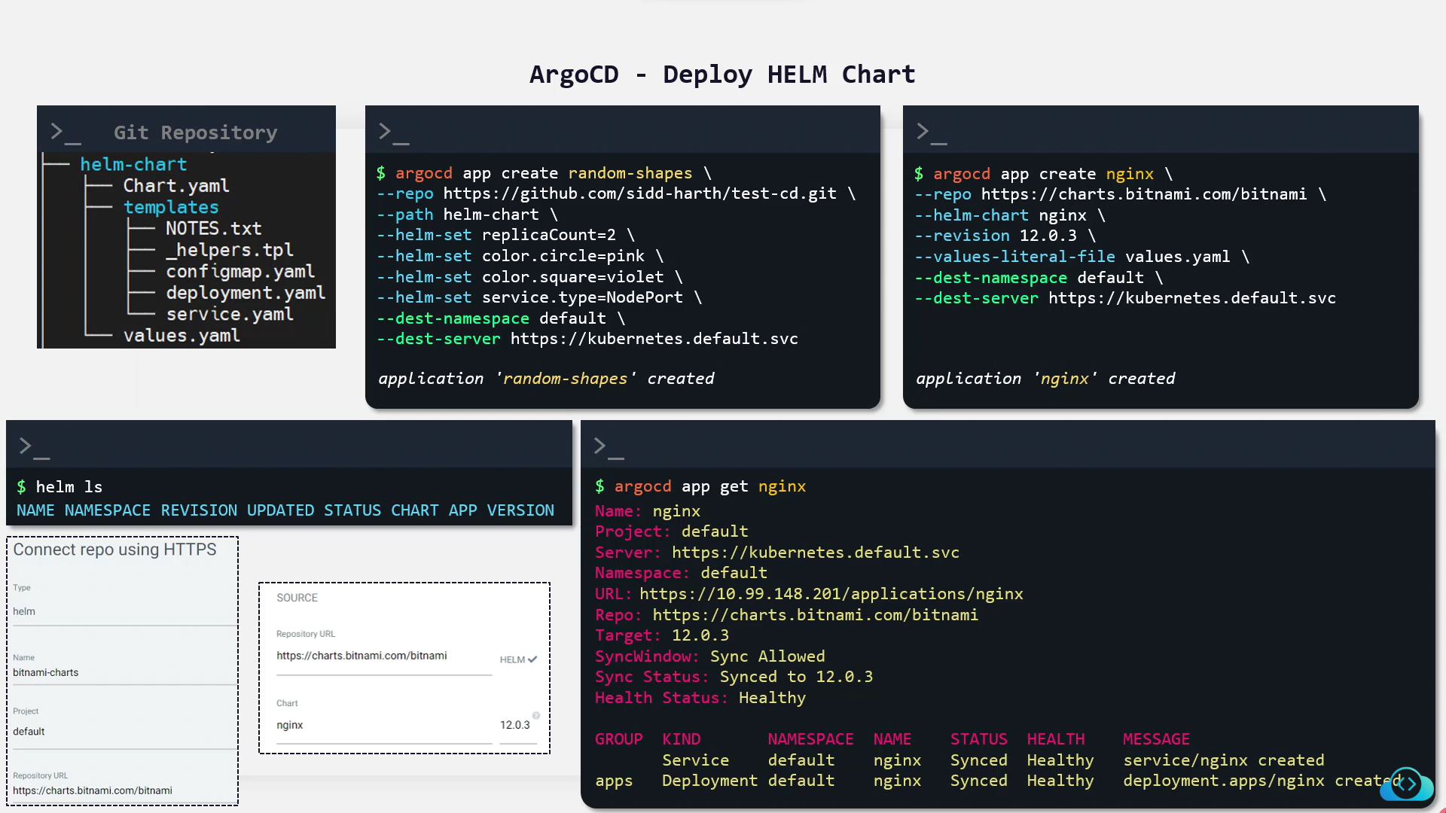

Multi-cluster application deployment

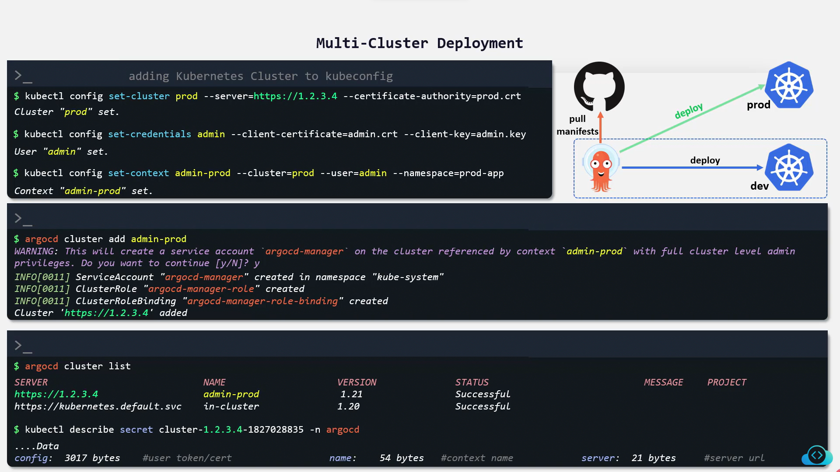

**ArgoCD Advanced**

User Management & RBAC (ArgoCD)

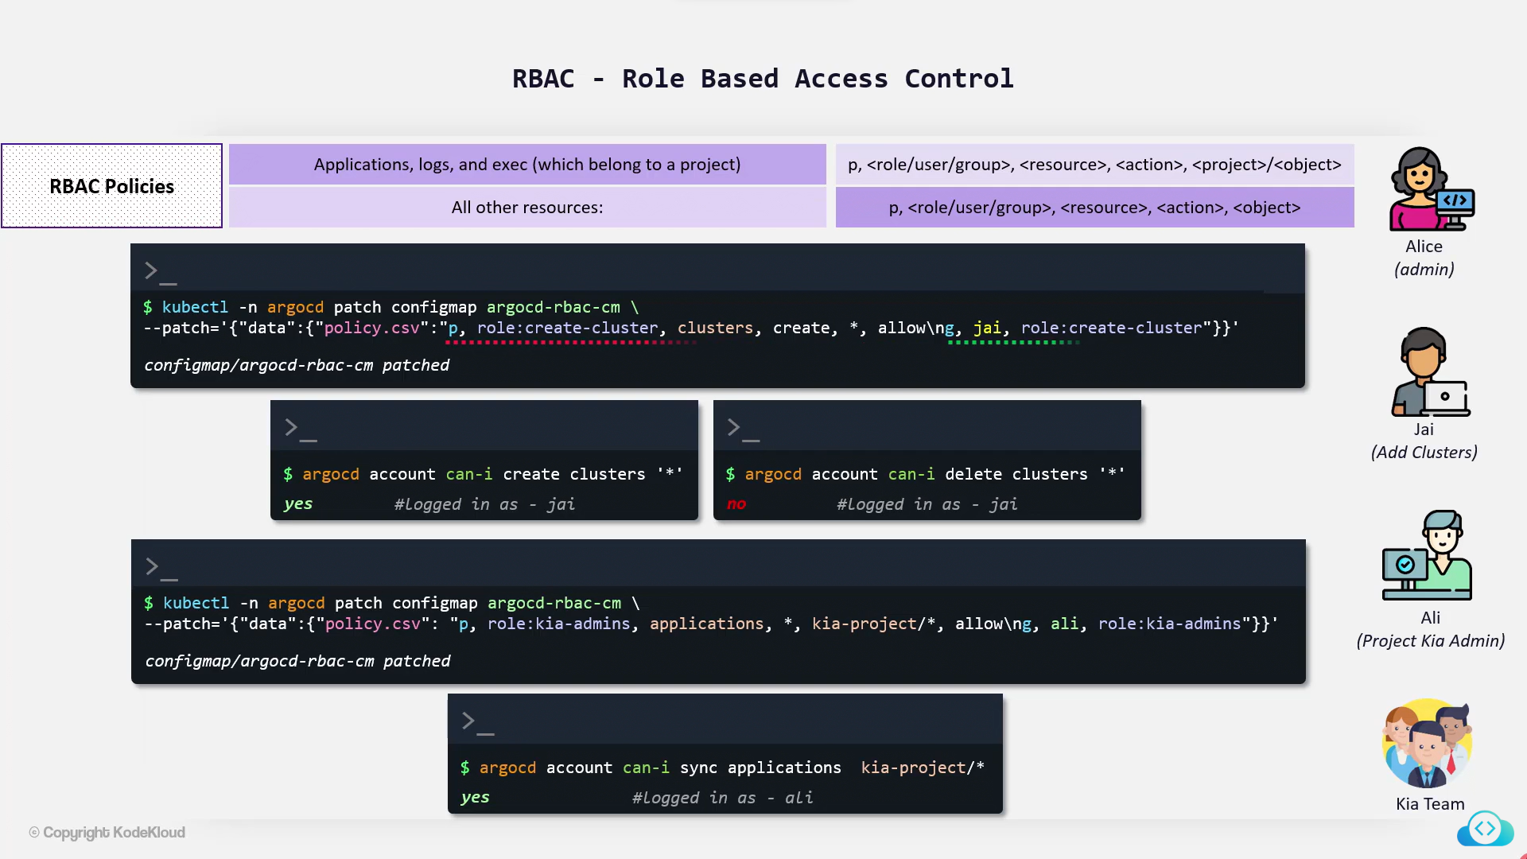

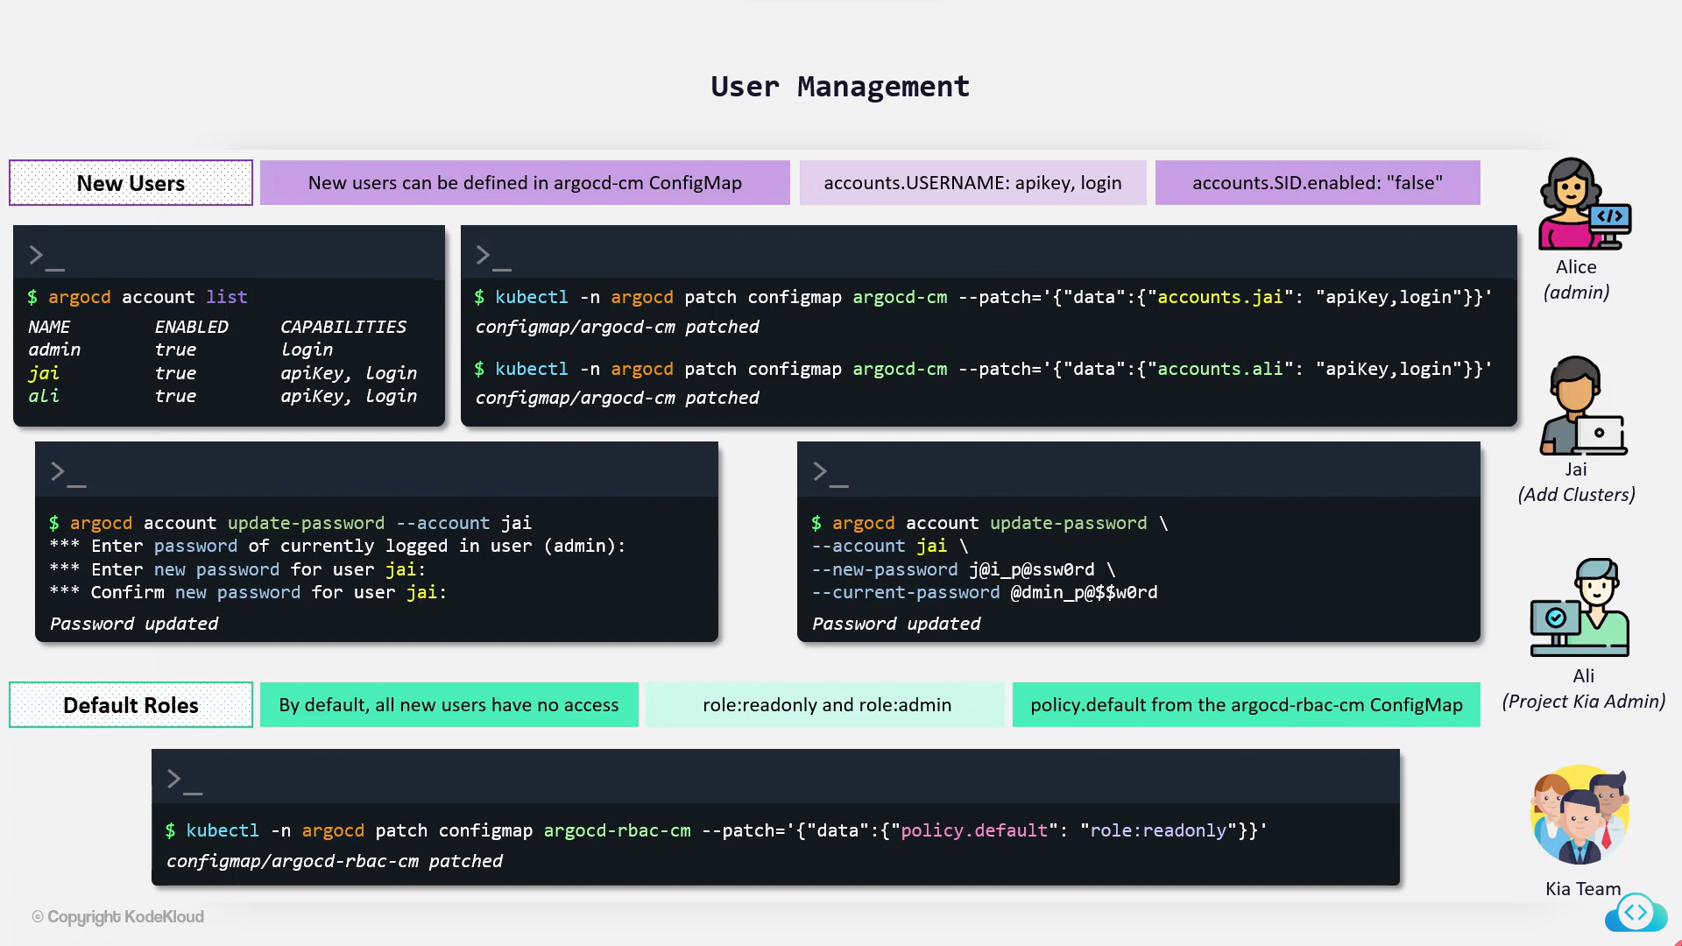

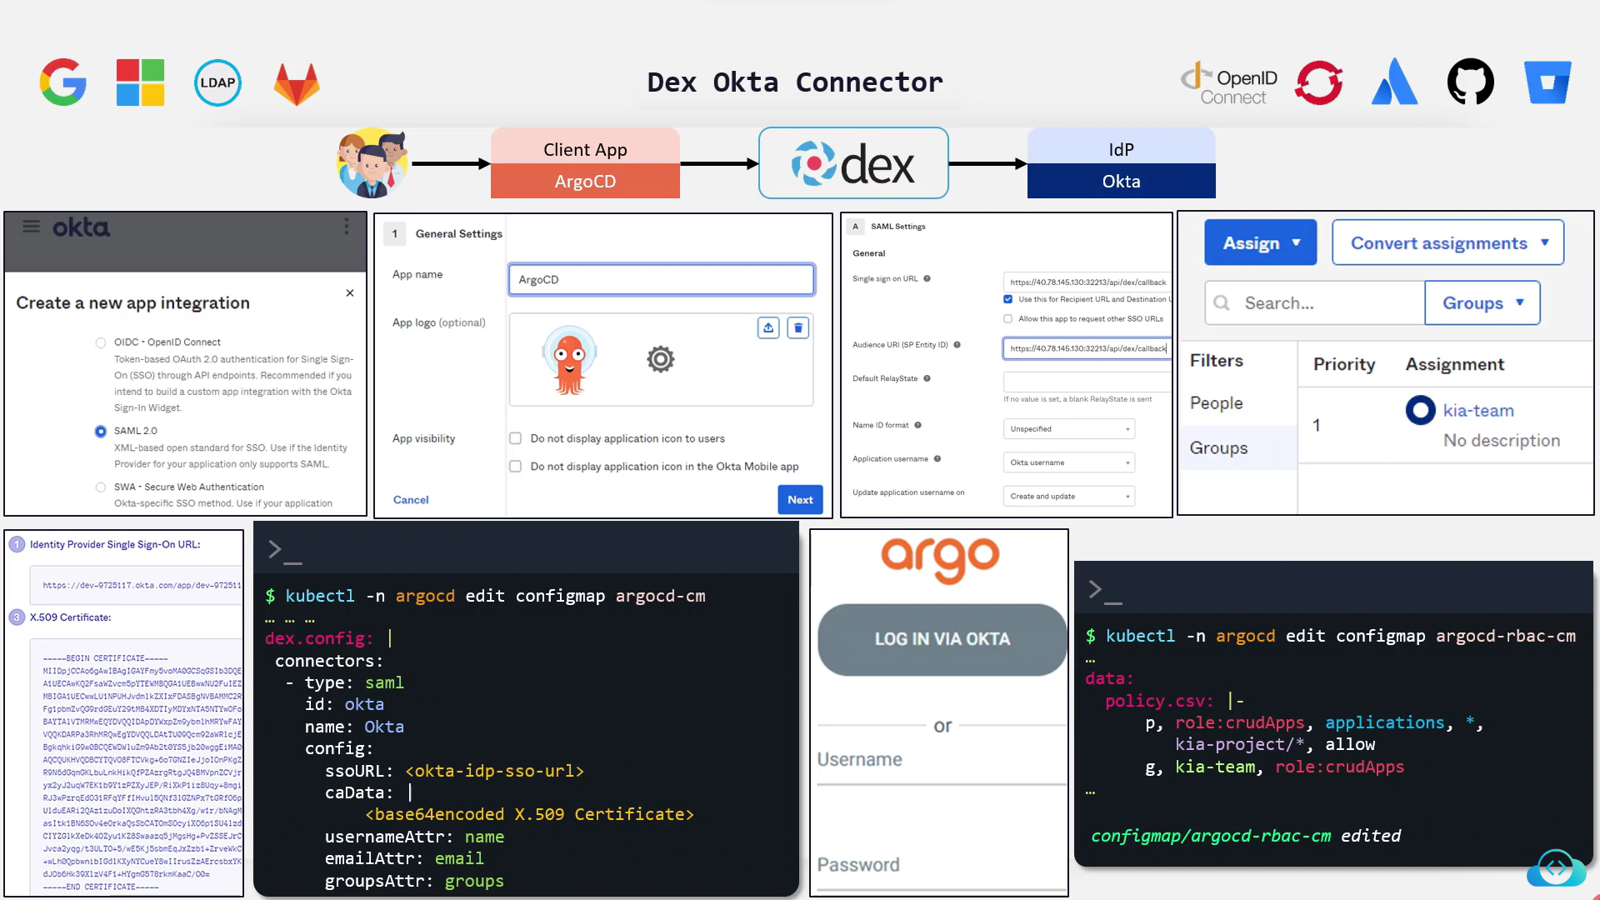

Bitnami Sealed Secrets

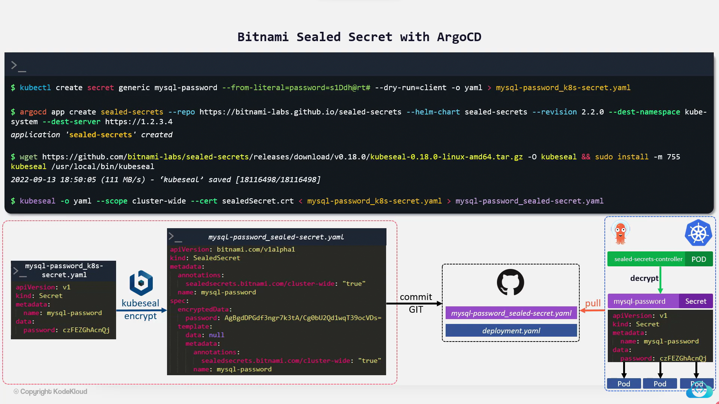

HashiCorp Vault with ArgoCD Vault Plugin

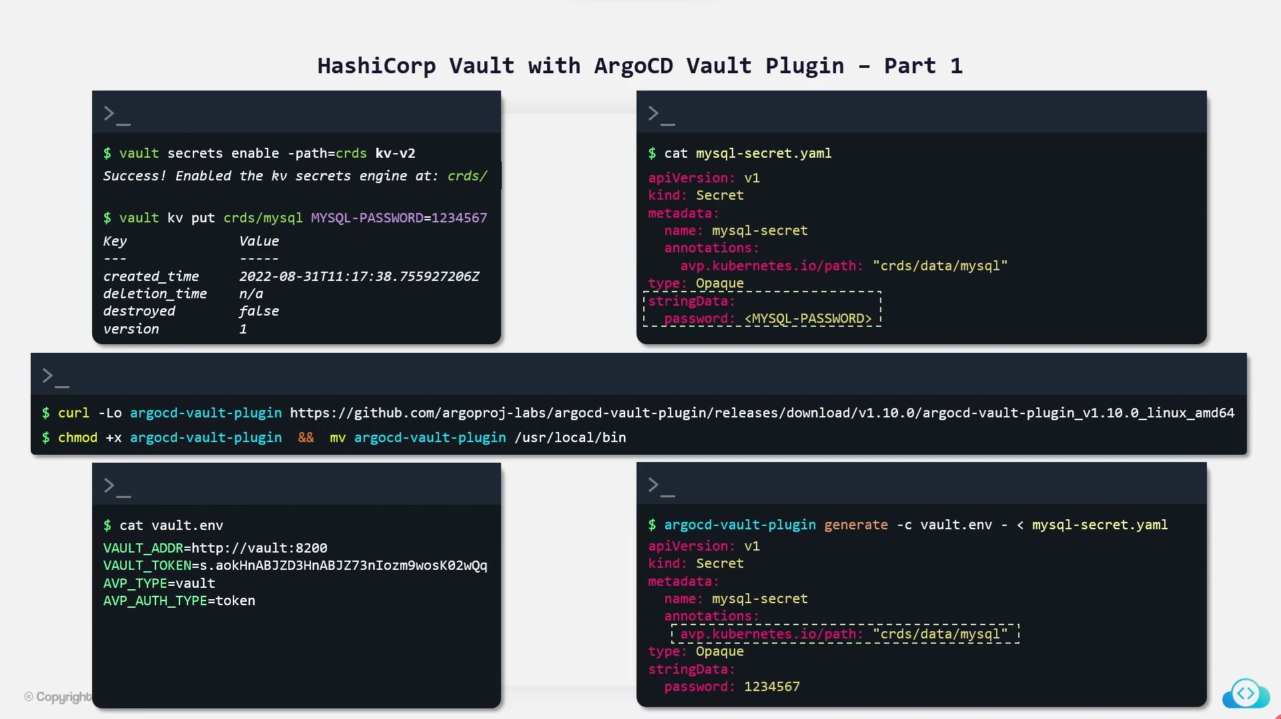

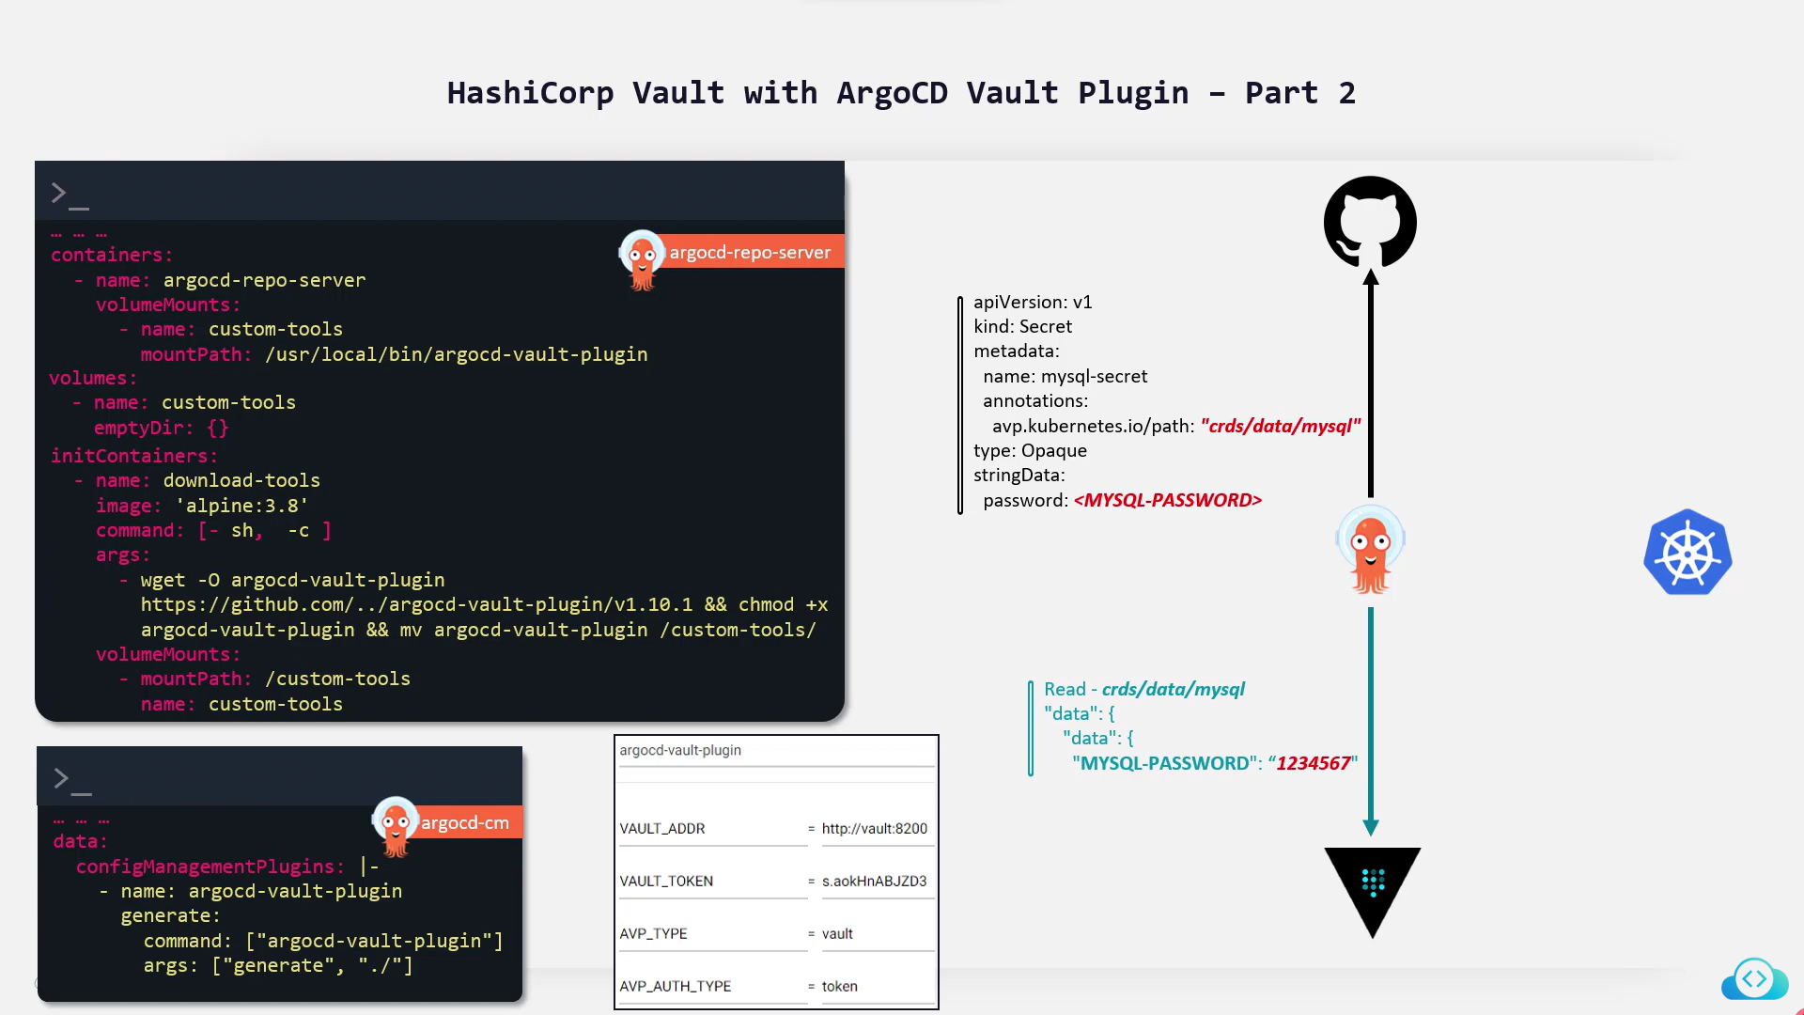

ArgoCD Metrics and Monitoring

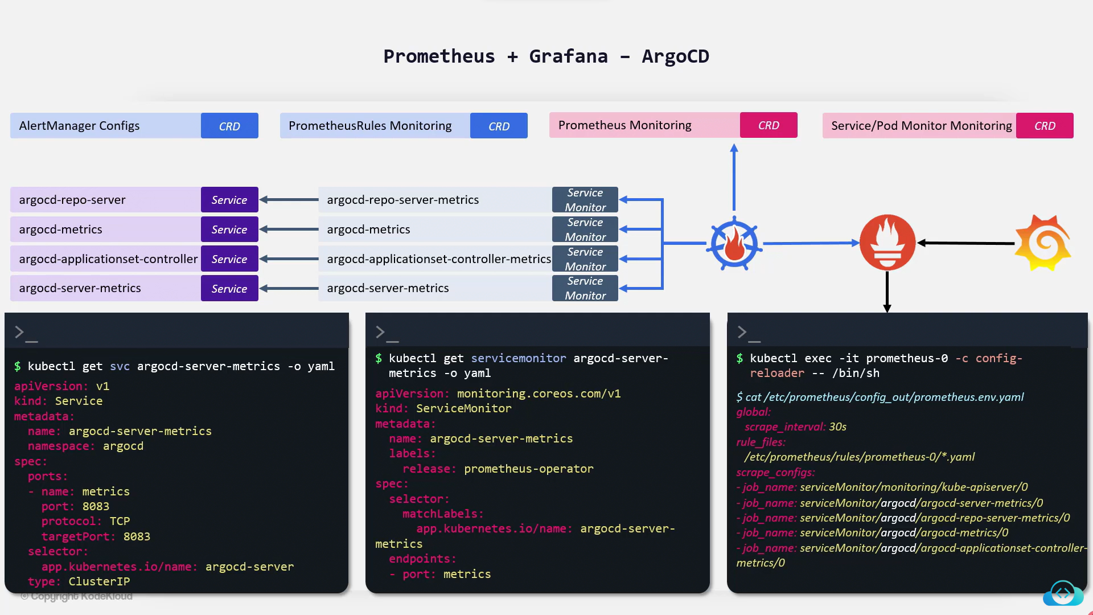

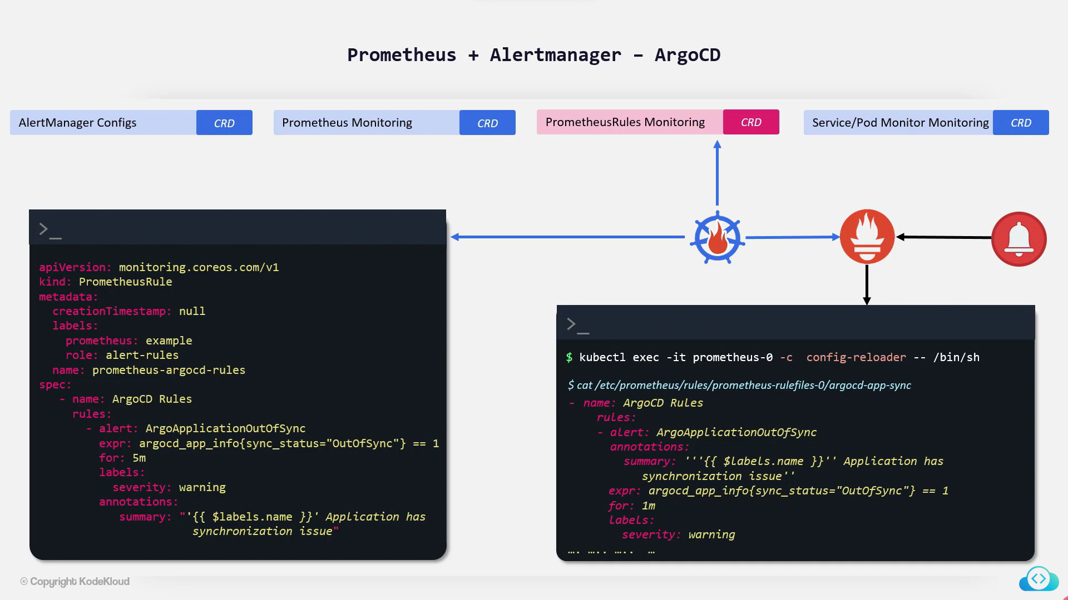

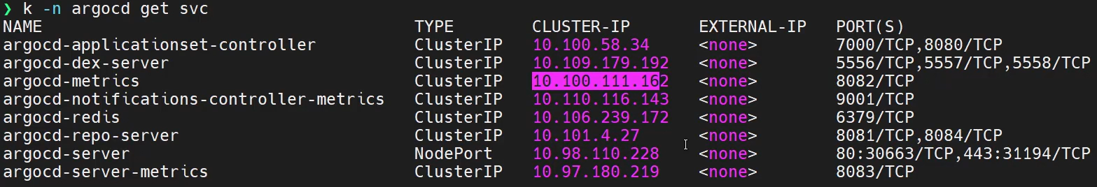

Lab – Monitoring through Prometheus + Grafana & Lab – Raise alert using AlertManager

**ArgoCD Notifications**

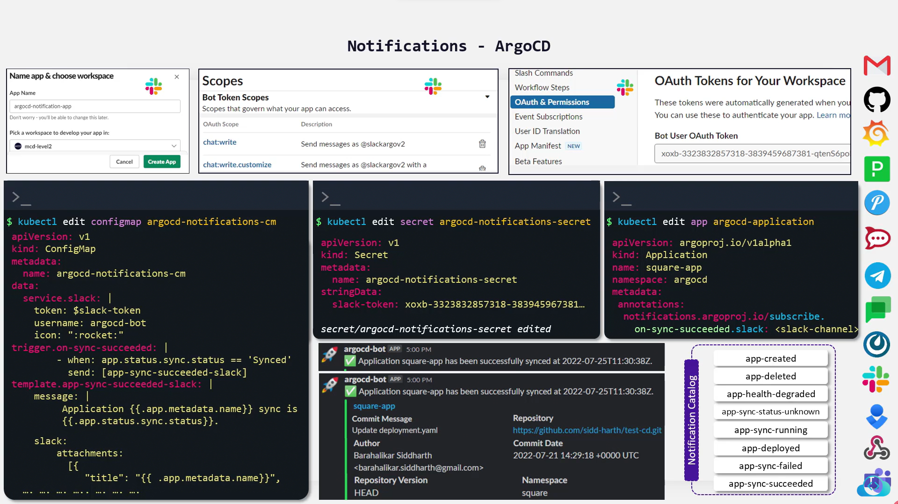

**ArgoCD with Jenkins CI Pipeline**

CICD with GitOps

